retirar militante do vocabolário do documento
manifestos=manifest MANIFEST

Election Markup
Language

SOFTWARE SYSTEM DOCUMENT FOR A DAPP DESIGNED TO IMPROVE COMMUNICATION WITHIN POLITICAL PARTIES

Document Revision History

Date | Version | Description | Author and co-authors
2019 | 0.0a | Initial draft | lightningrod
17-12-20 | 0.1 | Skeleton guide for alpha production | lightningrod
2021-08 | 0.2 | Beta development SSD | ?
2022-? | 0.3 | Final product documentation | ?

COMMONS LICENCE (LICENÇA DE DISTRIBUIÇÃO DESTE DOCUMENTO, O MAIS FREE POSSÍVEL)

We suggest a first look at this document by skipping the suggested readings at each chapter and for the developers to do a second reading by going through each of the suggested links.

A cryptosystem should be secure even if Oscar knows all the details about the system, with the exception of the secret.
Motivation

Manifestos. . . . . . . . . . . . . . . . . . . . . . . . . . . . 7

Liquid democracy . . . . . . . . . . . . . . . . . . . . . .9 direct + representative = liquid
Electronic vote . . . . . . . . . . . . . . . . . . . . . . . . 11 e-vote, e-governance, e-democracy

Study cases . . . . . . . . . . . . . . . . . . . . . . . . . . 12 Sinco program

Design considerations . . . . . . . . . . . . . . . . . . . . . . . . . .14

Web 3.0 . . . . . . . . . . . . . . . . . . . . . . . . . . . . . 15 decentralization

Distributed ledger . . . . . . . . . . . . . . . . . . . . . . 30 blockchains and smart-contracts

Scalability trilemma . . . . . . . . . . . . . 32

Relay modes . . . . . . . . . . . . . . . . . . . 20

Algorand . . . . . . . . . . . . . . . . . . . . . . 33

Eventually consistent databases . . . . .20

Matrix protocol . . . . . . . . . . . . . . . . . 20

Network maturity . . . . . . . . . . . . . . . 36 cryptocurrency economics

Cross-chains & other tools . . . . . . . . 37

Privacy . . . . . . . . . . . . . . . . . . . . . . . . . . . . . . .22

Identity management . . . . . . . . . . . . . . . . . . . .17 biometrics, Sybil resistance

Reputation . . . . . . . . . . . . . . . . . . . . .24

Trust . . . . . . . . . . . . . . . . . . . . . . . . .20

Mitigation . . . . . . . . . . . . .. . . . . . . . 27

Standards

Cryptographic primitives . . . . . . . . . .38

DID . . . . . . . . . . . . . . . . . . . . . . . . . 20

FIDO2 . . . . . . . . . . . . . . . . . . . . . . . .20

Quantum crypto. . . . . . . . . . .. . . . . . . . . . . . . .38 search for quantum-proof algorithms

System versions. . . . . . . . . . . . . . . . . . . . . . . . 39

Smartphone. . . . . . . . . . . . . . . . . . . . 41

Architecture

Hardware

Open source SoC . . . . . . . . . . . . . . . 20

Trusted Execution Environment . . . 30

Overlay network . . . . . . . . . . . . . . . . . . . . . . 20

Running environment . . . . . . . . . . . . . . . . . . .99

Software

Dependencies . . . . . . . . . . . . . . . . . .20

MAGI stack. . . . . . . . . . . .00

Modules . . . . . . . . . . . . . . . . . . . . . .20

Data model . . . . . . . . . . . . . . . . . . . .20

State diagram . . . . . . . . . . . . . . . . . .16

Authentication . . . . . . . . . . . . . . . . .31

Minimum viable product . . . . . . . . . . . . . . . . . . . . . . . 20 dynamics, views

Authorization . . . . . . . . . . . . . . . . . . . . . . . . 22 understanding decentralized politics

Document templates . . . . . . . . . . . . . . . . . . . 20 file output

Crowdfunding . . . . . . . . . . . . . . . . . . . . . . . . 30

Interface wireframe

Landing page . . . . . . . . . . . . . . . . . 18

Wall . . . . . . . . . . . . . . . . . . . . . . . . 22

Profile . . . . . . . . . . . . . . . . . . . . . . . 22

Institutions . . . . . . . . . . . . . . . . . . . .20

Forum . . . . . . . . . . . . . . . . . . . . . . . 22

Program . . . . . . . . . .. . . . . . . . . . . . 20

Debates . . . . . . . . . . . . . . . . . . . . . . 20

Eco-econometric report. . . . . . . . . . 20

Hemicycle . . . . . . . . . . . . . . . . . . . . 19

Milestones

Audio transcription . . . . . . . . . . . . . . . . . . . . .20

A.I. political compass . . . . . .. . . . . . . . . . . . . 20

Collaborative development . . . . . . . . . . . . . . . . . . . . . 30

End-user license agreement (EULA) . . . . . . . . . . . . . . 20

Other interesting links . . . . . . . . . . . . . . . . . . . . . . . . . .20

Manifestos

" Democracy through the internet is perhaps be the only way to return to the parliaments the true voice of the people, we, citizens and voters.
After all, what other alternative we have to conduct a real political debate under one roof when the population amounts to millions? The internet is that "home".
We must also realize how useful politics is and devote some of our free time to study it. It is urgent to work on new ideas that are more in line with the objectives to which we set ourselves to do and also with the century in which we live in.
Time and time again we have come across the appalling consequences of unregulated capitalism; increasing inequalities and usurpation of natural resources by a small percentage of the population in the name of profit.
Also communism has demonstrated time and time again in many countries and different contexts that it is important that society rewards effort and does treat distinctly those who make sacrifices in their personal and professional lives and those who do not at the risk of impoverishment!
Does it still make sense to think of left and right, progressive and conservative, as was done in the seventeenth century? Or is it time to overcome this paradigm and understand that we all have various beliefs and different life experiences and that it is nonsensical to fit people into labels?
Who and what is the state anyway? What should the taxes be used for and how are they regulated? The state and the set of all public institutions belong in fact to all of us, and therefore, to no central authority. Anyone can enter public office at any time. On the same the way he or she who takes public office may also be invited to leave at any moment if democratic consensus decides so.
Political ideas are far from ideas set in stone; But it is safe to say that the only and main functions of the state are to promote equal opportunity in accessing the natural resources of the land, by providing education, medical treatment in promoting health and access to courts and true justice. Planet earth in its natural state is itself the greatest wealth that humans possess. Living in a community means more than the equitable use of minerals and gases, and other God-given natural resources. It also means in a way the need to share the accumulated knowledge of the generations past and the freedom of mobility anywhere in the public space, be it forests and rivers, the splendour of natural landscapes, access to the biodiversity of species, a clean atmosphere, the cyberspace, in short, what the common sense tells us, communal resources are all physical and non-physical assets that intrinsically belong to all of us and should never ever be subject to the control of a select few, be it a minority, group or an individual.
The state must promote equal access to all of these resources and leave it
up to the individual what to do.
Political stability is a basic requirement for social progress. War has never brought real benefit to anyone, not even to those who won. There is the false idea between some of us that war forces progress and that the most important technological advancements were made during such periods. This couldn’t be farther from the truth. It is in times of peace when humanity comes together that great discoveries are made. Peace is a basic human need.
That is why it’s also increasingly urgent to make politics more transparent. Citizens have every right to know up to the smallest detail and at any moment how taxes are used and who benefits from them. Of course this goes against the will of many "installed powers" (so-called). It is not in the interest of big multinationals or the most influential politicians that perpetuate their influence in politics well beyond the appointed term to make democracy more transparent. It is a path that still needs to be carved which cannot be done without great union between the majority of the population.
What is real policy?
To share the resources that belong to us all and
therefore to no one in particular. It’s means at the same time
protecting the labour of the individual.
It is to bring solidarity to those that feel they have no support.
To have a project that involves the whole community.
And bring hope to those who lost it.
And take food where hunger is.
To do something beautiful, honourable and pleasurable.
By doing good for others without judgment.
And unite the people and not separate them.
And rise those who fell.
And give them a hand.
In conclusion,
real policy is to join forces in
solidarity in building a more inclusive society.
Rich and fair.
And that is very easy. "

Liquid democracy

Before beginning the technical part of the present document we should introduce what liquid democracy means because the goal of building this software is to help implement liquid democracy in large organizations (that may be spread geographically). It is:

“Liquid Democracy, a superset “of Delegative Democracy, is a powerful voting model for collective decision making in large communities. Liquid Democracy combines the advantages of Direct Democracy and Representative Democracy to create a truly democratic voting system that empowers voters to either vote on issues directly, or to delegate ones voting power to a trusted party. People may vote directly on any issue they so choose, or assign votes to others that they trust to represent their views on a specific issue. They may portion representation on issues to different individuals. Individuals build reputations based on previous voting record – and by building networks of trust. If a person is unhappy with how someone has voted or is representing their view, they may recall their vote.
Delegative Democracy, or liquid democracy, lies between direct and representative democracy. In direct democracy, participants must vote personally on all issues, while in representative democracy participants vote for representatives once in certain election cycles. Meanwhile, liquid democracy does not depend on representatives but rather on a weighted and transitory delegation of votes. Delegative democracy is a form of democracy whereby an electorate has the option of vesting voting power in delegates rather than voting directly themselves. Voters can either vote directly or delegate their vote to other participants; voters may select a delegate for different issues. In other words, individual A of an X society can delegate its power to another individual B – and withdraw such power again at any time.
Delegative democracy through elections should empower individuals to become sole interpreters of the interests of the community, region or nation. It allows for citizens to directly vote on policy issues, delegate their votes on one or multiple policy areas to delegates of their choosing, delegate votes to one or more people, delegated to them as a weighted voter, or get rid of their votes’ delegations whenever they please.”

Exert taken from Bureau of Cascadian Public Affairs

It’s a clever way to keep the benefits of direct democracy while also retaining the benefits of representative democracy!
The reason representative democracies first appeared during CENTURY?! was because that at that time the human population was on the rise to a point where it became more and more difficult to reach consensus within large groups due to physical constraints in the space of the Agora. During this period, there were no cell or land-phones whatsoever, no TV or radio communications and the internet then was not even a mere idea in the minds of the best scientists and philosophers. Were we to bring someone from the past to the present world, we’d be accused of being able to communicate with each other through some form of telepathy. The world has without a doubt changed a lot since then. Today we are able to send messages quickly across the globe, start video calls and see each other in real time regardless of the distance that separates us, to the moon and back.
The piece of the puzzle that is missing is an application designed much in the same way as most of popular social networks, but specifically for political discourse.
The time for liquid democracy has come. No more is there a need to delegate all of our important decisions at the hands of a person who, in most of the cases, we bear no relationship with. How many of us are close friends with our elected officials? Also from now on we’ll be able to punish more assertively those who promise one thing and change their attitude by quickly revoking their delegate status.
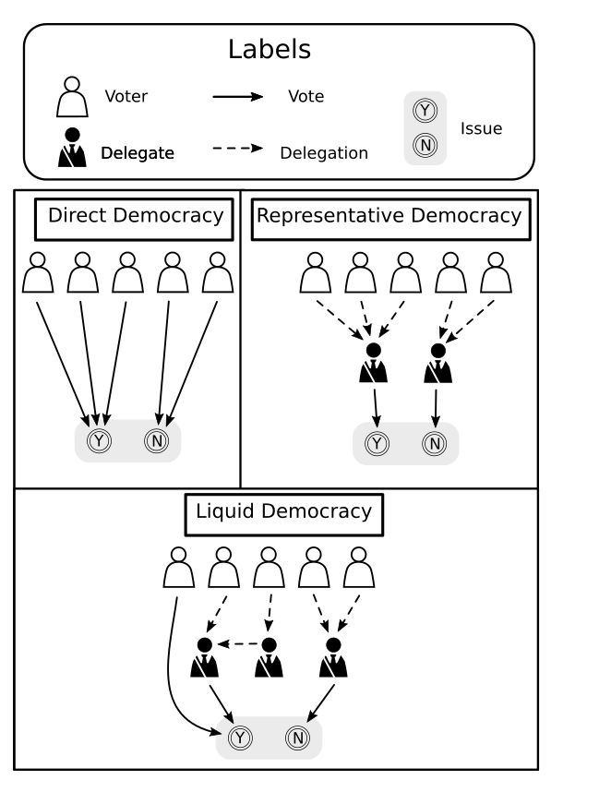

Picture 1) Graphical representation of a democratic system that is liquid.

Suggested readings:

“Delegative Democracy” by Brian Ford, https://bford.info/deleg/deleg.pdf

“Liquid Democracy: True Democracy for the 21st Century”, https://medium.com/organizer-sandbox/liquid-democracy-true-democracy-for-the-21st-century-7c66f5e53b6f

Wikidemocracy, https://en.wikipedia.org/wiki/E-democracy#Wikidemocracy

Open-source governance, https://en.wikipedia.org/wiki/Open-source_governance

“Peer governance and Wikipedia: Identifying and understanding the problems of Wikipedia’s governance” by Vasilis Kostakis, Tallinn University of Technology, 2010, https://firstmonday.org/ojs/index.php/fm/article/view/2613/2479

Electronic vote

The tension between democracy and the use of the internet is thus evident. It suffices to point out events taking place during the Arab Spring or more recently the rioting in Portland, America, perpetuated by Antifa group, or on a more humorous side Trump’s constant tweets. All of these political events took place or began in discussion groups on social media platforms, some with important consequences such as the overthrow of local governments.
Electronic vote is the ability to trace a vote cast over the internet to its originator on a given topic. It’s a different form of engagement from standard social media in the sense that there is a higher expectation concerning identity management and database integrity. E-vote is a practice that’s becoming more common in particular when voting abroad for national, or during EU elections in Europe.
However to date, it has not been extended to include all kinds of political events despite the enormous progress made in informatics mainly due to scepticism regarding on-line security. Many academics still maintain that on-line voting is insecure and that we are far from having a reliable system. Here we make the case that most if not all of these concerns are unfounded or have been surpassed by new and recent advancements in decentralised software systems. Why this has not been mediatized sufficiently or brought to attention by the current political establishment we leave to the reader to ponder. Maybe it’s the case that the science behind it is hard to comprehend, or it maybe so that we have a deep preconceived notion that cybersecurity is impossible to achieve as we have become used to constantly hear about violation of privacy by hackers and multinationals. Maybe there is an inherent friction to change in political organizations or maybe there is something else that lies outside the scope of this document and should be addressed by social sciences. Regardless, it might be interesting to note that already a big part % how much? of our economies is digitized. Smart cards account for a % of the total monetary transactions already and in countries such as in Sweden physical currency is becoming less and less used. Somehow we trust our money to be transacted with digital services but fail to do the same with our votes.
The hopes is that by deploying the most advanced blockchain technologies and integrating biometric data, smart cards and by making sure that all the software is open source for anyone check that there is no malicious code embedded, a robust case for massive e-vote adoption is made. This does not mean that the system we propose is 100% secure against hackers. There will always be attempts to usurpation of identity but the goal here is to marginalize these acts and be able to identify and correct them whenever they may occur in a timely manner.
Whenever an electronic vote is cast a ticket can be printed with a QR code that can be used for record keeping and later verification (the Supreme Court of Germany recommends that voting machines leave a paper trail).

Suggested readings:

Online petition entry on Wikipedia, https://en.wikipedia.org/wiki/Online_petition

e-participation entry on Wikipedia, https://en.wikipedia.org/wiki/E-participation

Electoral fraud entry on Wikipedia, https://en.wikipedia.org/wiki/Electoral_fraud

“A sampling of election fraud cases from across the country” found on The Heritage Foundation, https://www.whitehouse.gov/sites/whitehouse.gov/files/docs/pacei-voterfraudcases.pdf
“The Future of Voting, End-to-End Verifiable Internet Voting, Specification and Feasibility Assessment Study”, U.S Vote Foundation, Galois, USA, 2015.
link

“A Review of Contemporary E-voting: Requirements, Technology, Systems and Usability” by King-Hang Wang et al., Hong Kong University of Science and Technology, Kowloon, Hong Kong, 2017.
http://www.ikelab.net/dspr-pdf/vol1-1/dspr-paper3.pdf

“The Ballot is Busted Before the Blockchain: A Security Analysis of Voatz, the First Internet Voting Application Used in U.S. Federal Elections”, MIT, year?.
https://internetpolicy.mit.edu/wp-content/uploads/2020/02/SecurityAnalysisOfVoatz_Public.pdf

Study cases

Talk about Estonia as example for national elections
There are a few examples where what we are proposing in this document has already been done. One of such examples can be found in the extreme east, modern and capitalist South Korea where local government has conducted an on-line referendum in the province of Gyeonggi-do in 2017. The entire process from casting the votes to counting and subsequent validation was successfully carried on-line without the need or intervention of any private management or central authority.
The best example of using e-vote(Sinco is not a voting platform but a political bulletin board) in political organizations though can be found in south America’s communist country Venezuela. There the government launched an on-line platform entitled Sinco where any citizen can publish a policy proposal that if met with sufficient momentum then becomes an official public offer. An important part of the national budget was assigned to this project HOW MUCH? which is still running at the moment.


Picture 3) Logo of Sistema de Integración Comunal.

Sinco is a computer application with its UI based on Google Maps where users can create topics regarding policies that are signalled in the map. Topics vary from building new public infrastructure to financing private projects that the community votes on. It was launched in… and it’s a successful case of integration of software in policy making.

Picture 4) Sistema de Integración Comunal’s UI.
“ This paragraph is the interpretation of the facts learned by the present author in a conversation with Venezuelan authorities. Lessons to be taken from their experience (Sinco program) are one of accountability. That means that with e-voting being massively adopted and introduced into public organizations governments are incentivized to increase public spending; there is a natural demand for better public infrastructures, a more active role in foreign affairs, etc.. This increase in spending if not properly supervised can lead to situations where the money is not being correctly applied and this is what we define as the problem of accountability. A proper system of checks and balances, of supervision has to be put into practice parallel to the use of on-line voting platforms. Not only the way citizens communicate within political parties and the way laws are created needs to be improved but also we should consider revising most of the political system to accommodate for these changes. That is to say that in order to achieve the goals that we set ourselves to do in this document’s manifesto it is not sufficient to create an application but some aspects of politics need to be reformed as well which is logical if we consider that most of the current political party statutes, for example, were created in the 17th century past. The system needs revision mostly to consider accountability and to combat corruption (wrong allocation of money). This is the experience to be learned from our Venezuelan friends and we should always keep that in mind; people were democratically reaching consensus for certain projects, proposed by non-politicians as expected from an e-vote platform and the money was being allocated from public resources to these proponents. But in fact, unfortunately, after receiving the money many times it would end up being used for other more obscure private goals. A proposal for some of the changes necessary to avoid these kind of situations is given in a document named “SPECIFIC STATUTES FOR A POLITICAL PARTY THAT IS SUPPORTED BY A DECENTRALIZED APPLICATION” that can be found in suggested readings no x. This document is an improvement over regular political party statutes that was considered fundamental to the creation of a more connected society but I acknowledge that other institutions need revision as well. ”

lightningrod

Technically, the difference from what has already been accomplished by the Sinco program to what is proposed here is mainly in terms of complexity of the system design itself at the application level such as in our proposal by having a more interactive user interface by adding video streaming which is absent in Sinco to integrating blockchain technology in order to reinforce cybersecurity. In all other aspects we can say that the Sinco platform is quite similar to what we pretend to achieve here by building this piece of software.

Suggested readings:

Electronic voting in Estonia entry on Wikipedia, https://en.wikipedia.org/wiki/Electronic_voting_in_Estonia

“Electronic voting: What Europe can learn from Estonia” on Official Microsoft Blog,
https://blogs.microsoft.com/eupolicy/2019/05/10/electronic-voting-estonia/

“South Korean Local Government Uses Blockchain Voting Technology” on KryptoMoney, https://kryptomoney.com/south-korea-uses-blockchain-technology-for-elections/

Sinco’s homepage, https://app.sinco.gob.ve/

Sistema de Integración Comunal’s Youtube channel,
https://www.youtube.com/channel/UCk863oG-kQ24x6WCfV8ivvA

“SPECIFIC STATUTES FOR A POLITICAL PARTY THAT IS SUPPORTED BY A DECENTRALIZED APPLICATION”, https://docdro.id/Cqruxsg

Design considerations

Building software is not a one way road. Different solutions may be of equal value and often the choice of which frameworks to use is just a matter of personal taste. This document was created with the intention of serving as a guide to whoever may want to create an application designed to promote communication within political parties and so in this section we talk about what we consider to be the key design aspects that regardless of the implementation need be present:

- Respect for privacy through tokenization.

- Protection against identity theft through proper identity management hardware and software including the use of biometrical data.

- Have a relatively low learning curve and barrier of entry to new users.

- Fully open source. Specify the importance of open hardware MIT License.

- Hardware universal and independent of OS (to promote user adoption).
This is going to be difficult…. Independent of OS is easier than hardware universality

- The database should be completely decentralized and not be dependent on any central server (node) owned by a single point of authority (to prevent corruption). As an exception a special kind of node can be setup as a relay for webRTC (anyone should be able to set it up if the hardware meets the minimum requirements).

- Should scale and perform well with a large number of users (numbers are expected to rise quickly).

- The interface design should be simple and intuitive enough to be used at its full potential by everyone including blind people and other users with all forms of handicap. This is not expected to be reached at MVP, but as it is an aspect often left secondary, we emphasize that we should strive to be as inclusive as possible for the full product. This includes using techniques such as high contrast options, audio-transcription and the ability to accommodate to different font and display sizes without losing functionalities.

- High standards regarding cybersecurity which includes, but is not limited to, the use of secure channels and the latest hashing methods as well as be up to date with the field of quantum-proof algorithms.

- Should progressively, as the software matures, integrate geographic information systems and other graphical user interfaces designed to ease the creation of policies in diverse areas such as territorial planning, preservation of the environment and transportation, to name a few, as well as other UIs that facilitate political discourse and identification such as the use of a hemicycle representation with real-time analysis of the political procedures occurring in the world. Likewise a section dedicated exclusively to eco-economical data analysis should be considered.

- And obviously, the software is designed to help implement liquid democracy in large organizations; users should be able to publish ideas on new policies and these publications should be voted or delegated to other peers in a much similar way to posts published and shared among current popular social networks by the use of “like” and “share” button.

Suggested readings:

“Formalising security properties in electronic voting protocols”, Stephanie Delaune and Steve Kremer, France, 2013.
http://www.lsv.fr/Projects/anr-avote/RAPPORTS/deliv1-2.pdf

“The Future of Voting: End-to-End Verifiable Internet Voting: Specification and Feasibility Study”, Joseph R. Kiniry et al., Overseas Vote Foundation, USA, 2015.
http://people.csail.mit.edu/rivest/pubs/OVF15.pdf

“End-to-end verifiability”, Josh Benaloh, Ronald Rivest, Philip Stark et al., 2015.
https://arxiv.org/abs/1504.03778

“Was YOUR vote counted? (feat. homomorphic encryption)” on Numberphile (Youtube) by Ron Rivest, Stanford University, 2017. https://youtu.be/BYRTvoZ3Rho

“A framework for comparing the security of voting schemes”, Atte Juvonen, University of Helsinky, 2019.
https://www.attejuvonen.fi/thesis-voting-security-2019-10-01.pdf

“Remotegrity: Design and Use of an End-to-End Verifiable Remote Voting System” by Richard T. Carback et al., 2013. https://eprint.iacr.org/2013/214.pdf

“EVIV: An end-to-end verifiable Internet voting system” by Paulo F. et al., 2013. https://www.researchgate.net/publication/257006739_EVIV_An_end-to-end_verifiable_Internet_voting_system

EVIV github repo, https://github.com/EVIVoting/EVIV

“BeleniosRF: A Non-interactive Receipt-Free Electronic Voting Scheme” by Pyrros Chaidos et al., 2016. https://eprint.iacr.org/2015/629.pdf

“ESIV: an end-to-end secure internet voting system” by Nafise Mohammadi Shakiba et al., Electronic Commerce Research, 2017. https://www.researchgate.net/publication/305040101_ESIV_an_end-to-end_secure_internet_voting_system/link/5a0b3704458515e482748669/download

“Ordinos: A Verifiable Tally-Hiding Remote E-Voting System” by R. Küsters et al., EU Symposium on Security and Privacy, 2020. https://eprint.iacr.org/2020/405.pdf

ElectionGuard, https://microsoft.github.io/electionguard-python/

“Provotum: A Blockchain-based and End-to-end Verifiable Remote Electronic Voting System” by Christian Killer et al., University of Zurich, Zurich, Germany, 2020.
https://www.researchgate.net/publication/345319094_Provotum_A_Blockchain-based_and_End-to-end_Verifiable_Remote_Electronic_Voting_System

Provotum, https://github.com/provotum/provotum-v2
“Fasten: Fair and secure distributed voting using smart contracts” by Sankarshan Damle et al., International Conference on Blockchain and Cryptocurrency, 2021.
https://arxiv.org/pdf/2102.10594.pdf

Web 3.0

The internet was created early in the 1970s by the hands of 2 physicists that were researching ways to transfer considerable amounts of data between two computer terminals that were located in two distinct labs separated kilometres apart without the hassle of handling and transporting disks back and forth. It was at its infancy a data transfer protocol layered on top of an ethernet infrastructure. It has since then expanded; Google was launched in 1998 followed by Facebook in 2004 and Youtube in 2005. Today it has 4,66 billion users. To accommodate for this expansion, and because a regular single computer terminal could not transfer its data to multiple terminals at the same time without slowing down communications, a server-client architecture was designed where the server would not be an ordinary computer but a more expensive hardware upgraded version with better storage and data transfer capacity. While this was technically a sound solution to accelerate communications it put the server terminals in the privileged position of holding most of the data that was circulating on the internet and placed the client terminals in a role more akin to mere presenters of the data. Cloud computing is the pinnacle of this technology and it is there that this architecture shines the most. This is web 2.0.
Web 3.0 is a controversial term originally thought up to encompass recent advancements mainly in machine learning such as AI semantics coupled with the increasing network bandwidth and the continuous evolution of the Moore’s law and internet availability in the IoT. We argue however that another equally powerful innovation lies in improvements in data distribution; web 3.0 is a radical change (paradigm-shift) in the internet architecture and where the analogy of a “world wide web” becomes most apparent. The server-client paradigm is dropped and everyone is invited to participate equally on the network. Some participants might still be working as servers, or a cluster of servers in the sense that they have more computational power than others and perform specific roles, while other participants might be simple low-end single computer terminals that merely present the data, but the right to participate in the distribution of the data and the right to validate its integrity, that is to validate that no third party has tampered with its composition without proper authorization from all the other nodes, is equally given to everyone. This remarkably clever idea was first realized by Satoshi Makamoto and is the idea behind bitcoin.

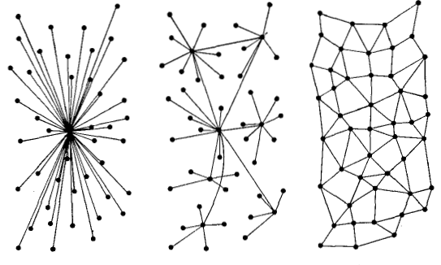
Picture 5) From centralized web (1.0) on the left to distributed on
the centre (2.0) and decentralized to the right (3.0).

The reason web 3.0 is becoming increasingly more popular is not because it addresses rapidity of data distribution, this was already solved by web 2.0. In fact, at the present state, it is considerably slower. The reason it’s interesting is that it offers a more secure environment than the traditional server-client architecture that is single-point fallible; if the server goes down (or a cloud service provider for that matter) for what-so-ever reason the whole network goes down. This could happen due to power shortages, cyberattacks on the server or, not the least likely, it could be made shut down by arbitrary decision of the service provider. By being completely decentralized web 3.0 is more resilient to this type of events. If a node (participant) is shut down or is compromised, the whole network stays up and continues functioning as expected, just slower.
Federated can be considered something in the middle between distributed and decentralized?

Picture 6) Federated architecture as presented by www.8bitmen.com.

From completely centralized or even distributed systems to completely decentralised there’s a spectrum
Web 3.0 is a vaster term than cryptocurrencies or blockchain because while the first term encompasses all aspects of “democratic distribution of information” the second focuses on applications in monetization of information and the last one is specific to database operations. It’s clear by now that a revolution is unfolding in the Defi space (decentralized finances). This revolution is expected to impact the way FIAT currencies are evaluated, stocked and exchanged. Payments using crypto currency are already happening in festivals in Thailand; during Mystic Valley Festival more than a 1 000 000 USDs were transacted with 15 000 payments processed. Our project however lies outside of Defi and lands in the Dao space (decentralized autonomous organizations). The fact is that at the present moment Defi has been the centre of attention for the developers community in comparison to Dao and our hopes is that this work will help bring some balance.
It is unclear how these two branches of the web 3.0 will interplay with each other in the future but we can certainly say that both will be present in some form or another in our society.

Suggested readings:

“The Decentralized Web Explained (in Words You Can Understand)” by Corin Faife, https://breakermag.com/the-decentralized-web-explained-in-words-you-can-understand/

“Distributed Ledger Technology:
beyond block chain, A report by the UK Government Chief Scientific Adviser”,
https://assets.publishing.service.gov.uk/government/uploads/system/uploads/attachment_data/file/492972/gs-16-1-distributed-ledger-technology.pdf

“Turkey Can’t Block This Copy of Wikipedia”, https://web.archive.org/web/20171018092720/http://observer.com/2017/05/turkey-wikipedia-ipfs/

“Mystic Valley Festival: Mobile Payments Deployed with Success on Fuse!” on Medium, https://medium.com/fusenet/mystic-valley-festival-mobile-payments-deployed-with-success-on-fuse-9804b3790818

What is the internet computer?, https://dfinity.org/, https://youtu.be/lA2ySwYDQoo

InterPlanetary File System, https://ipfs.io/

“Eventual vs Strong Consistency in Distributed Databases” by Saura on Hacker Noon, https://hackernoon.com/eventual-vs-strong-consistency-in-distributed-databases-282fdad37cf7

“A protocol for decentralized video conferencing with WebRTC”, white paper by Andreas Hallberg at KTH Royal Institute of Technology, School of Information and Communication Technology in Sweden, 2016
https://kth.diva-portal.org/smash/get/diva2:1081457/FULLTEXT01.pdf

https://www.youtube.com/watch?v=4zh808bU6L4

Distributed ledger

Distributed ledgers, or distributed networks, or closely related federated networks, are “is consensually shared and synchronized across multiple sites, institutions, or geographies, accessible by multiple people “ “ consensus of replicated, shared, and synchronized digital data geographically spread across multiple sites, countries, or institutions.[1] Unlike with a distributed database, there is no central administrator.[2] “ difference between distributed and decentralised
Blockchains are encrypted, distributed (decentralise?) and signed databases. They are not applications or processes designed to do any computation with the stored data itself which in our case would be the names and votes for policy proposals. In contrast to traditional databases which follow the CRUD model where data can be Created, Read, Updated and Deleted, blockchains are RW, Read and Write only. Once data is submitted to the blockchain it can’t be changed as long as the network is on-line although new blocks can be added. In our case we could name it a vote-chain. Votes are cast, stored, distributed (without recurring to a middle man? Central authority?) and thus should remain unchangeable over time and it is this immutability that is of interest to us.
Smart contracts differ in that they are small programs that are designed to read the data from a blockchain, do some operations with it and instructed to write back new blocks (updated data) with the results. The middle step between reading and writing a new block can contain a varying degree of code. An example of an open source platform where this could be achieved would be using Ethereum as a blockchain and Solidity as a programming language to code the smart contract. Another aspect that makes smart contracts different from ordinary blockchain transactions or regular computer operations is that they define a set of rules by which the on-chain data can be manipulated. If a number of parties agree to participate in a smart contract then they cannot manipulate the transactions (data transfer) in any way that is not stipulated by the contract without first resigning. This is particularly useful when we want to do logical operations that involve many different parties that may try to break the rules to which they agree.
Consensus is what-ever mechanism that is used to ensure that each node in the network is operating conveniently (submitting legal transactions). In case a malicious node attempts to propagate erroneous data the consensus algorithm should be able to pin-point the event and alert the rest of the network.
Distributed ledgers in general are very secure. Their major vulnerability, other than the traditional Ddos and the already mentioned Sybil attack in some applications, are what the blockchain developer community calls the 51% attack.
When dealing with large files such as documents (which sometimes could be Autocad files, or SVG images to name a few file types) with sizes larger than, say 100kb, that by itself renders it difficult to impossible to store them on a distributed ledger because DLs need to be by their own nature very light. It’d be nonsensical to even try to replicate the entire internet across each node; there is just too much data circulating. We are forced because of physical constraints to pre-configure and impose limitations to what is to be replicated on each node of the network by prioritizing sensitive information. The best approach is to assume that each node may at most 10 GB of hard drive capacity, 2 GHZ of CPU clock speed, 4 GB of RAM space and 20 MB network bandwidth (given the current status quo). The clever idea here is to instead of storing files themselves on-chain, to store only their hashed values and their IP addresses necessary to routing. This idea inspired by other applications such as BitTorrent has been implemented by two peer-to-peer file distribution systems; one named InterPlanetary File System (IPFS) and the second one Filecoin. ... and address large amounts of static data by distributing immutable (permanent) tables (DHT). How does it work more precisely?
As of today there are around 1000+? different blockchains on-line, each with a slightly different, and sometimes not so slightly, implementation. Different blockchains can then cooperate with each other to achieve functionalities that on their own would not be possible. The question now becomes which technology best adapts to the needs of our application.

Suggested readings:

CockroachDB, https://www.cockroachlabs.com

https://youtu.be/zaE1VXRREVg

List of top frequently asked blockchain questions and answers at javaTpoint, https://www.javatpoint.com/blockchain-interview-questions

Ethereum, ethereum.org

“Ethereum vs Hyperledger” on Blockchain training alliance, https://blockchaintrainingalliance.com/blogs/news/ethereum-vs-hyperledger

“Here’s the difference between ‘permissioned’ and ‘permissionless’ blockchains”,
https://thenextweb.com/hardfork/2018/11/05/permissioned-permissionless-blockchains/

“Blockchain Consensus: A Simple Explanation Anyone Can Understand” on Blockgeeks by Ameer Rosic, https://blockgeeks.com/guides/blockchain-consensus/

“Proof of work algorithm based on random code execution”, https://github.com/tevador/RandomX

“What is Blockchain Governance: Ultimate Beginner's Guide” on Blockgeeks,
https://blockgeeks.com/guides/what-is-blockchain-governance-ultimate-beginners-guide/

The DAO (organization) entry on Wikipedia,
https://en.wikipedia.org/wiki/The_DAO_(organization)

Agora white paper,
https://static1.squarespace.com/static/5b0be2f4e2ccd12e7e8a9be9/t/5f37eed8cedac41642edb534/1597501378925/Agora_Whitepaper.pdf

Distributed social network entry on Wikipedia,
https://en.wikipedia.org/wiki/Distributed_social_network

“A Survey of DHT Security Techniques” by Guido Urdaneta et al, VU University, Amsterdam, The Netherlands, http://www.globule.org/publi/SDST_acmcs2009.pdf

“A Review of Techniques to Mitigate Sybil Attacks” by Nitish Balachandran et al, https://arxiv.org/abs/1207.2617

“A Survey of Solutions to the Sybil Attack” by Brian Neil Levine et al, United States of America, https://nymity.ch/sybilhunting/pdf/Levine2006a.pdf

Scalability trilemma

The “Scalability trilemma” is a term first coined by Vitalik Buterin the founder of Ethereum and refers to the trade-offs that a blockchain must decide when projecting the underlying architecture. The trade-offs involve three components; decentralization, security and scalability. Although fundamental to blockchain these constrains can be considered relevant to distributed systems in general These are not independent variables but are in fact quite interrelated:

Decentralization; this is the ability of a blockchain to store data across multiple nodes (terminals, servers). This is the feature that guarantees anti-censorship and promotes network resiliency and is at the core of blockchain technology.
Scalability; in most use cases the blockchains need to process thousands of transactions (operations) per second. Whether we are talking about Defi or Dao the ability to quickly process all the information regardless of scale is required. It suffices to acknowledge that every day 1100? financial transactions are made worldwide and for each transaction a number of checks must take place. Dao systems which are expected to function in a similar manner to social networks are doing 10100? publications daily (an example taken from Twitter). When a blockchain system is highly decentralized the scalability becomes a challenge as all the participants on the network need to be updated concurrently.
Security; because blockchains are expected to deal with sensitive data they are also expected to be hack-proof. Data immutability is a technique used in all implementations but special care must also be taken to protect against 51% attacks, Sybil attacks, DDoS, etc..
Different approaches are made by different blockchains and often they imply resigning one of parameters mentioned above. For example, blockchains that employ EeoS type consensus achieve scalability and security without compromising network speed by allowing only a limited number of nodes to operate on the network. (search example by taikai). Other blockchains rely on mining pools to achieve all three desired features by increasing the cost of doing operations on-chain. While this is acceptable in theory it does not respect the decentralization requirement because mining pools are expensive to run and that places a monetary constraint on the users allowed to participate in consensus (mine).
In order to store data files such as PDF, images, etc. required when presenting policies, a specific mechanism designed to secure big files should be used; at the moment of writing there is File Coin and Interplanetary File System as valid options. By placing the hash address of the files in notation fields of blockchain transactions… This timestamps and secures content without having to distribute the data itself.
At the moment of writing there’s only one organization claiming to have completely solved the trilemma and that organization is Algorand.

Suggested reading:

“The Scalability Trilemma in Blockchain” on NeonVest co-authored by Surya Viswanathan and Aakash Shah, https://medium.com/@aakash_13214/the-scalability-trilemma-in-blockchain-75fb57f646df

“What Is the Scalability Trilemma?” on bitorb by Rand Low, https://www.bitorb.com/campus/what-is-the-scalability-trilemma/

Fallacies of distributed computing entry on Wikipedia, https://en.wikipedia.org/wiki/Fallacies_of_distributed_computing

Relay modes

Customized content relay: users may opt to relay specific data videos:

Minimum relay for dapp stability? For example how many users must replicate a video so that it is readily available worldwide for a given audience? What if the demand for that content changes over time how can the network respond?

Given the limited resources of each apparatus; smartphone, laptop, desktop, server, cloud, etc..

What roles are expected to be attributed to each node?

Suggested readings:

Algorand

Blockchain operations have high computational costs because of their distributed nature. For each new block that is added the whole network needs to be updated and consensus algorithms need to be run. This high computational cost is also one of the reasons why these types of networks are so resilient to attacks.
Proof-of-Work, the consensus mechanism behind the most popular blockchains, is a process that divides the user base in three separate groups each with its own interests; Miners, pool operators and the users themselves. Miners are practically not concerned with network security or decentralization; they are just mercenaries who have economic incentives and want to maximize their profits. By having their own costs for electricity etc. to cover, they virtually instantly sell their mined coins. These operational costs are called gas fees. When the demand for operations on the network is high and the distributed computational power is low (for lack of sufficient nodes for example), gas costs go up while the opposite may also happen. Because of scalability issues Ethereum’s gas prices are at an all times high costing about ?.?? $ to do example of operation. Ethereum monetizes these costs by allowing users to “passar a frente na fila” by paying a gas fee in ether (Ethereum tokens). Bitcoin, because it does not give native support to smart contracts, does not need to tackle this issue; most demand for network activity comes from smart contract operations.
In 2017, Silvio Micali came up with the idea of creating a new consensual algorithm that would allow blockchains to scale and retain a high level of security and decentralization; users in Algorand become those who take care of network security. This is an ideal scenario where within a particular ecosystem roles of the nodes are not divided. The consensual decision-making power is homogeneously distributed into a maximum number of independent entities. He called the consensus mechanism Pure Proof-of-Stake (PpoS). In PpoS new blocks are generated according to the amount of stake (token holdings) an account owns. An account who holds, for example 20% of the total amount of tokens in circulation in the entire chain is given the task of generating a new block with 20% probability. There are no special roles for any user such as being a miner. However this type of consensus is still similar to PoW blockchains in the sense that if a user holds a considerable portion of the circulating tokens, 50% or more for example, the chances of becoming the new block generator are such that the criteria for decentralization is somewhat lost.
To prevent this situation from ever happening, launching and expansion of the blockchain network needs to be planned in a special way. The idea is that an initial pool of tokens is mined by a trusted group. This is the only time tokens can be mined in PpoS blockchains. We call the initial participating nodes seeds and the first blocks the genesis blocks; in Algorand’s main-net this trusted group of initial “miners” is called The Foundation. By the time the genesis blocks are finished new users can join the chain by invitation only and begin to stake. Then, as the network matures (more users join), the initial pool of tokens that belonged to the trusted founding group need to be slowly given overtime to the new participants whom The Foundation deemed to also to be trustworthy. We assume that if a bad actor during this process would try to bribe a trusted party in order to gain control of a considerable amount of the network tokens would see its initiative denied (the Foundation acts in good faith). Overtime as the network matures the initial pool of tokens associated with the genesis blocks are spread over so many accounts, some of which by then might be untrustworthy, that a bad actor would need to bribe too many users to effectively gain control over a large percentage of the network so much so that it becomes uneconomical to realize.
At the present time Algorand’s main-net although past its embryonic stage can still be considered to be in its infancy. A proper study of its current evolution is made in the next chapter.
Algorand’s approach to its economics is also more democratic than other blockchains; it has a fixed gas price and its users need to wait for their transaction to be executed on a first-in-first-served basis. While most blockchains in order to minimize operational costs separate mining-pools from “regular” nodes rewarding machines running these services by giving them cryptocurrency, Algorand’s economy runs on the opposite principle that no reward is given to the accounts of users running these special services. Whether the node is providing consensus or not running any service is all the same. What Algorand does is distribute cryptocurrency periodically between all the accounts in some sort of Universal Basic Income.
At this moment (17/09/2020) the gas fee to participate in a smart contract is 0.05 algos and to issue a smart contract 1.00 algos need to be spent. Doing a transaction has a cost of ?.?? algos. The current rate at which an account is automatically increased is proportional to the stake owned by that account and at the present moment is averaged to about ?.?? algos per day. This “fee” can be calculated by the formula found on the link. Also each new account in Algorand is credited with a balance of ?.?? algos upon creation. By not allowing mining of tokens users are also deterred from spending algos without discretion giving the network and economy some stability.
Using a fast and reliable distributed ledger with no gas fees (operating costs) is impossible. Whenever we are writing an operation on-chain we have to pay. Likewise when a user opts to participate in a contract (in our case that would mean to vote on a poll) a fee is also paid. This doesn’t mean that in order to use our dapp the users must buy algo with real money but it does mean that the number of operations a user can do is limited in time.
We opt in the design of our dapp to issue our own digital asset which for simplification we’ll simply call a vote token and program it in a way that it cannot be exchanged with any other cryptocurrency in order to to prevent users with more economical power from buying more vote tokens thus participating more than other users with less financial capacity. This can be achieved with Algorand as the blockchain was designed with these situations in mind. At the end of the day what this means is that at most one user can create a new contract (create a new poll in our dapp) every ? or so days or vote on polls x times per day unless the poll of we inject algos in the vote tokens poll depends on the number of nodes running full archival on algorand?
From August 2020 onward Algorand also officially supported stateful smart-contracts. The novelty is that these contracts can guarantee not only fast transactions and block generation but also hold up to 16 global variables and 100 local variables for each account that signs to a contract. Each variable can hold up to 65 bytes of information. The global variables can be accessed from other smart contracts as well. In this way the network’s capacity to do complex logic was highly increased in comparison to stateless smart-contracts before. Still, for a complex dapp such as the one we purpose here it remains impossible to do all the logic and save all the dapp data on-chain. Taking this into consideration the following golden rule should be considered during dapp development:

“Do your logic off-chain as much as possible then secure big files on a secondary specialized blockchain such as the likes of IPFS or Filecoin and do minimum but necessary contractual computation on Algorand.”

Overall it’s one of the fairest blockchains present in the crypto space from a democratic perspective, however because of this same reason it is one of the networks with less nodes operating in it in full archival mode. The future of the stability and resilience of Algorand depends on the voluntary servicing of new nodes as the demand for the network increases.

Commentary on algorand’s relay “white list” by Patrick on discord: You can connect It was discussed in a forum post as well. I’ve discussed it countless times and at least on my phone don’t want to retype it. You can connect to any relay and configure node with any list of relays. There’s just a ‘default’ which is via a dns record (also configurable)

Suggested reading:

“Algorand's Core Technology (in a nutshell)” on Medium by Silvio Micali,
https://medium.com/algorand/algorands-core-technology-in-a-nutshell-e2b824e03c77

“Algorand and the solution to the blockchain trilemma: security, scalability, and decentralization” on Codemotion,
https://www.codemotion.com/magazine/dev-hub/blockchain-dev/algorand-and-the-solution-to-the-blockchain-trilemma-security-scalability-and-decentralization/

“Algorand Wants to End the Blockchain Trilemma” on BitBoy Crypto by Ben Armstrong,
https://bitboycrypto.com/algorand-wants-to-end-the-blockchain-trilemma/

“Algorand’s Smart Contract Architecture” by Silvio Micali,
https://www.algorand.com/resources/blog/algorand-smart-contract-architecture

“Example Permissionless Voting Stateful Smart Contract Application” on Algorand Dev Portal by Jason Weathersby, https://developer.algorand.org/solutions/example-permissionless-voting-stateful-smart-contract-application/?utm_medium=email&_hsmi=94525636&_hsenc=p2ANqtz-9dCYqU6uh4w3IAn_0_TC-nVoRuRSZ3i47GIt-LXVhQFsRScChWetpiNq7EURvsrSpyXz_QXITTtt8wdUYQnzRfSepjOA&utm_content=94525636&utm_source=hs_email

Example Algorand Smart Contract for Permissioned Voting on GitHub,
https://github.com/algorand/smart-contracts/tree/master/devrel/permissioned-voting

“Understanding the technicalities behind the pure proof-of-stake protocol Algorand uses”, https://community.algorand.org/blog/understanding-the-technicalities-behind-the-pure-proof-of-stake-protocol-algorand-uses/

“Permissionless polling web application on Algorand blockchain” found on GitHub, https://github.com/bafio89/blockandpoll

Eventually consistent databases

Achieving absolute synchronicity between multiple computers in different geolocations with large amounts of data is virtually impossible……..

Companies with big infrastructure like GOOGLE have access to atomic clocks and optical fibers and special access to satellites? Given that data is transferred at light speed they might not face consistency issues as badly as a software that relies on private networks……… but is relying on google infrastructure decentralised if all of its infrastructure is owned by one company? No

ACID vs BASE

USER SPACE VS GLOBAL SPACE……. USER SPACE – EXPLICAR no caso de GUN

https://en.wikipedia.org/wiki/Eventual_consistency – escrever o meu resumo disto
https://www.allthingsdistributed.com/2007/12/eventually_consistent.html
https://www.techopedia.com/definition/29164/basically-available-soft-state-eventual-consistency-base

Suggested readings:

GUN, https://gun.eco/

Matrix protocol

COMMUNICATIONS PROTOCOL that allows END-TO-END ENCRYPTION….. … cross signing multiple users… real time
Can be used for communications where all you want is…. But to secure data integrity (vote validation etc..) it is not sufficient. WHY exactly? = is eventually consistent?

Suggested readings:

The Matrix’s official frequent asked questions, https://matrix.org/faq/

“E2E Encryption by Default & Cross-signing is here!!”, in Element’s blog by Matthew Hodgson, https://element.io/blog/e2e-encryption-by-default-cross-signing-is-here/

Matrix’s threaded messages; Cerulean, https://github.com/matrix-org/cerulean

“Ecosystem review” by Jay Graber from Twitter’s project Bluesky, https://ipfs.io/ipfs/QmdFrru4PyHzXGZztEPnYToBR3QovD7fkC1HSyty22LzfD

https://www.youtube.com/watch?v=wdy3lUxYxuU

https://appdistribution.firebase.dev/i/394600067ea8ba37

https://github.com/staltz/manyverse

Network maturity

Who owns most of the algorand tokens at the present moment?
How many nodes are running full archival mode?
How many accounts on algorand exist? How are they spread geographically?
What’s the value of 1 algo at the moment?

Ipfs?

What monitoring tools can be developed?

Suggested readings:

monitoring tools? = blockchain validators distribution + network load + ENDPOINT MONITORING

Cross-chains & other tools

As mentioned in previous chapters we should aim to take advantage of blockchain specialization; our dapp should be running on Algorand to store and manipulate sensitive data, by doing transactions and saving new blocks that are noted with polls – votes – and hashes that function as links to other blockchains. To store some of the data on a regular server would defeat the purpose of decentralization and to do all the logic and save everything on Algorand’s main-net for example, or alternatively on a network created specifically for our dapp for that matter, would make the dapp too expensive if not impossible to run.
To fetch and use data from off-chain sources, such as when looking for eco-econometric data or scrapping data from public institutions websites an oracle (explain what an orable is) should be used; Chainlink is the most popular to date (atenção que a blockchain chainlink foi hackeada à pouco tempo!), but there are others which might be of interest (DECO or Town Crier)
Taking advantage of blockchain specialization is desired because it is expected that as the technology matures different blockchains will get better at doing specific things.
However, at the present moment cross-chains are unsupported by Algorand although this is a much anticipated feature that is promised to come in the near future updates. Nevertheless with the current code available some interoperability can already be achieved by making use of notation in transactions or by using global state variables in stateful smart-contracts that support cross-chain coupling.

ipfs+algorand – not really a cross-chain but the idea is the same

Suggested readings:

“A Secure Data Sharing Platform using Blockchain and IPFS” by M. Naz et al., 2019.
https://www.researchgate.net/publication/337712447_A_Secure_Data_Sharing_Platform_using_Blockchain_and_IPFS

“Securely share files on Algorand with IPFS” by Diego Said Anaya Mancilla, 2020.
https://developer.algorand.org/solutions/securely-share-files-algorand-ipfs/

Chainlink homepage, https://chain.link/

https://en.wikipedia.org/wiki/LBRY

https://lbry.com/faq/what-is-lbry

https://odysee.com/

Privacy

(not in distributed ledger chapter)
Voting was not always made in secrecy… ADD
Buying votes was a practice all too common where someone with economical advantage would bribe … this is why in ballots is made in secrecy. How can we replicate this feature in e-voting? What data needs to be public and what data must remain private in order to protect the voters from being harassed?

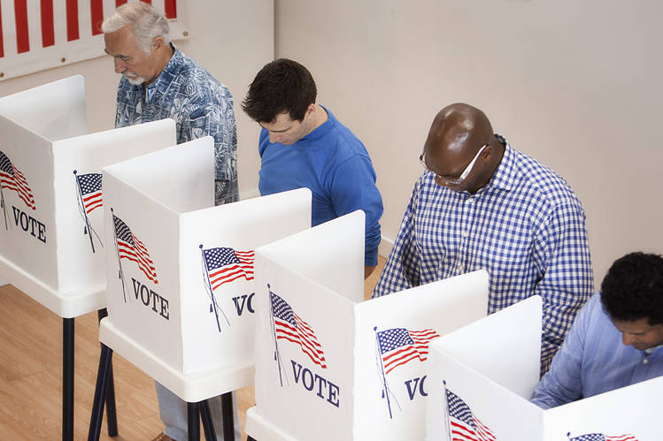
Picture 11) Voting booths in USA.

The question that naturally arises is how to keep the vote uncorrupted and safe in a database while at the same time being able to easily retrieve its information without necessarily exposing the sensitive data that came along with the vote, such as the identity of the voter, without consent (as some data needs to be accessible in order for electronic votes to be processed).
The results of a referendum should be relatively easy to verify while who voted for or against a certain policy must remain hidden from the public eye. At any time the system should allow verification of the integrity of the vote upon request from the respective owner. This can be achieved through a process known as tokenization; the use of hashing functions to store sensitive data. This is the mechanism used to store passwords. The sensitive data can be linked to public data so that when we need to retrieve some of the information we can do it without decryption while if we want to fully access it we can do it only by providing the correct keys. These are normal practices in modern banking in their on-line services and with e-commerce.
To summarize, when a vote is submitted a token is generated with the use of some hashing function. This token holds secretly the name of the original voter. Then the application automatically adds to the database the generated token along with the vote information that is public (which option from the poll of options was picked).introduce homomorphic encryption here In this way we guarantee privacy while also at the same time retaining some level of scrutiny. At any time the voter may look at the database where votes are saved and analyse the stored value and compare it to what it’s expected to be there.
Avoid Traceability to IP address? = TOR – vulnerable to timing attacks by state actors/ISP providers?
Additionally we must deploy a mechanism to prevent double voting, that is, that one same person is not able to vote more than once on a given poll. This can be achieved by using unique biometric features.
Achieving both criteria mentioned above without depending on a central authority figure is what we call the “Decentralized Identity Trilemma”.

Suggested readings:

Secret ballot entry on Wikipedia, https://en.wikipedia.org/wiki/Secret_ballot

Australian ballot entry on Encyclopædia Britannica,
https://www.britannica.com/topic/Australian-ballot

Data anonymization, https://en.wikipedia.org/wiki/Data_anonymization

Tokenization (data security) entry on Wikipedia,
https://en.wikipedia.org/wiki/Tokenization_(data_security)

Hash function entry on Wikipedia,
https://en.wikipedia.org/wiki/Hash_function

“Online Voting System using Homomorphic Encryption” by Saksham Saproo et al., Ramrao Adik institute of Technology, Nerul, India, 2020.
https://www.researchgate.net/publication/343284809_Online_Voting_System_using_Homomorphic_Encryption

“Multiplicative Homomorphic E-Voting” by Kun Peng et al., Proceedings of the 5th international conference on Cryptology in India, 2004.
https://www.researchgate.net/publication/225128215_Multiplicative_Homomorphic_E-Voting

“Homomorphic Tallying with Paillier Cryptosystem” by Sansar C., HSR, 2009.
http://security.hsr.ch/msevote/seminar-papers/HS09_Homomorphic_Tallying_with_Paillier.pdf

“Universally Verifiable MPC and IRV Ballot Counting” by Chris Culnane et al., 2019. http://www.ifca.ai/fc19/preproceedings/30-preproceedings.pdf

“Secure Electronic Voting using BlockChain and Homomorphic Encryption” by C. Sravani et al.,International Journal of Recent Technology and Engineering, 2019.
https://www.ijrte.org/wp-content/uploads/papers/v8i2S11/B11680982S1119.pdf

Cryptographic libraries by Provotum, https://github.com/provotum/evote-crypto

Free Haven, https://www.freehaven.net/

“Anonymity, Unlinkability, Unobservability, Pseudonymity, and Identity Management – A Consolidated Proposal for Terminology” by Andreas Pfitzmann & Marit Hansen, 2005. https://www.freehaven.net/anonbib/cache/terminology.pdf

“Secure User Identification Without Privacy Erosion” by Stefan Brands, University of Ottawa Law amp; Technology Journal 3, 2006.
https://www.freehaven.net/anonbib/cache/brands06.pdf

Onion routing entry on Wikipedia, https://en.wikipedia.org/wiki/Onion_routing

The Invisible Internet Project, https://geti2p.net/en/

“Privacy-Implications of Performance-Based Peer Selection by Onion-Routers: A Real-World Case Study using I2P”, Michael Herrmann & Christian Grothof, Technische Universit at Munchen, 2011.
freehaven.net/anonbib/papers/pets2011/p9-herrmann.pdf

Tor’s weaknesses entry on Wikipedia, https://en.wikipedia.org/wiki/Tor_(anonymity_network)#Weaknesses

Attacks-on-Tor repo on GitHub, https://github.com/Attacks-on-Tor/Attacks-on-Tor

“Improving Tor Security against Timing and Traffic Analysis Attacks with Fair Randomization” by Asghar T. et al., University of Guilan, Rasht, Iran, 2014.
https://www.researchgate.net/publication/270703823_IMPROVING_TOR_SECURITY_AGAINST_TIMING_AND_TRAFFIC_ANALYSIS_ATTACKS_WITH_FAIR_RANDOMIZATION

“Circuit Fingerprinting Attacks: Passive Deanonymization of Tor Hidden Services” by Albert Kwon et al., 24th USENIX Security Symposium, 2014.
https://people.csail.mit.edu/devadas/pubs/circuit_finger.pdf

“A technical summary of the Usenix fingerprinting paper” post on Tor’s blog, 2015.
https://blog.torproject.org/technical-summary-usenix-fingerprinting-paper

“Anonymity Trilemma: Strong Anonymity, Low Bandwidth Overhead, Low Latency —Choose Two” by Debajyoti Das et al, 2017, https://eprint.iacr.org/2017/954.pdf
“On the Economics of Anonymity” by Allesandro Acquisti et al., Financial Cryptography, 2003, https://www.freehaven.net/doc/fc03/econymics.pdf

“Garlic Cast: Lightweight and Decentralized Anonymous Content Sharing” by Chen Qian et al, 22nd International Conference on Parallel and Distributed Systems (ICPADS), 2016.
https://www.semanticscholar.org/paper/Garlic-Cast%3A-Lightweight-and-Decentralized-Content-Qian-Shi/6bc4e378327a61b3c35c1b95cd39eabc22abea01#paper-header

“TASP: Towards Anonymity Sets that Persist” by Jamie Hayes et al., Workshop on Privacy in the Electronic Society (WPES), 2016. https://www.freehaven.net/anonbib/cache/tasp-wpes16.pdf

“k-Indistinguishable Traffic Padding in Web Applications”, Wen Ming Liu et al, 12th Privacy Enhancing Technologies Symposium (PETS), 2012.
https://www.freehaven.net/anonbib/papers/pets2012/paper_46.pdf

Identity management

Regardless of how secure a piece of software is, even in the ideal situation where there is no open end or flaw in the software that can be exploited by a hacker that wants to take control of the flow of execution of a program, identity management still needs to be put into place in order to prevent users from creating multiple accounts or from stealing someone else’s identity. If no prevention mechanism is in use then what is stopping someone from creating an account and posing as a famous person, for example? Study how many times this happens for social networks such as facebook
IDM usually depends on central authority but it can be made decentralized. Systems that depend on central authorities generally have a lower entry barrier to new users and are in some sense more accurate than decentralized architectures. However this comes at the expense of trusting a third party with the task of managing identities which is not in the spirit our program. The best use case of central authority IDM is the use of smart cards issued by central governments:

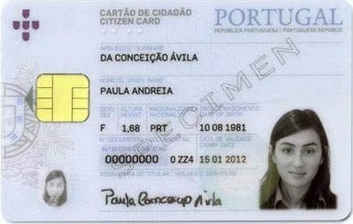
Picture 7) Portugal’s identity card specimen with integrated circuit.

Microchips were integrated into all French Carte Bleue debit cards in 1992. Today they mediate trillions of dollars. The first national eID card was issued in Finland in 1999. These smart-cards store encrypted digital certificates (digital signatures?) along with other relevant information. Another example of a public institution that uses this technology is the U.S. Department of Defence with its Common Access Card. If these smart-cards include bio-metric data, they can be used for enhanced two-or three-factor authentication (which we’ll make use in our decentralized IDM proposal). With the proper hardware we can implement IDM with governmental issued smart cards:

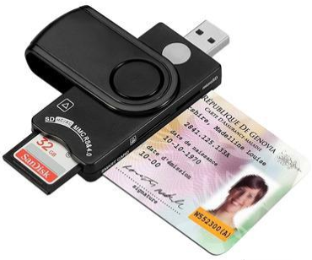

Picture 8) Smart card reader: https://www.newegg.com/p/0DS-00DB-00038

An effective solution to the identity management problem without any form of central authentication such as by using a smart card issued by a central government (or a QR code equivalent for example) may well be an utopic dream. Nevertheless it is a dream worth pursuing; smart cards should be supported by our dapp but not required. Supported, not required.
Another way to do IDM that does not require central authority is to make use of bio-metric features of the human body. To see how unique it is, for example, the human iris has more than 240 distinct features which vary from individual to individual and that is 5 times more than the distinct features of fingerprints. Also it may be interesting to notice that no two persons have ever been found to have the same fingerprints. But, who knows, in the future as population rises that may happen. But if we consider that not even two fingers of the same person share the same fingerprint chances of two persons sharing the same 5 fingerprints as well as the same iris and all the other facial features is dim. A rough estimate of the chances of that happening is about once every lifetime of our solar system^{x}.

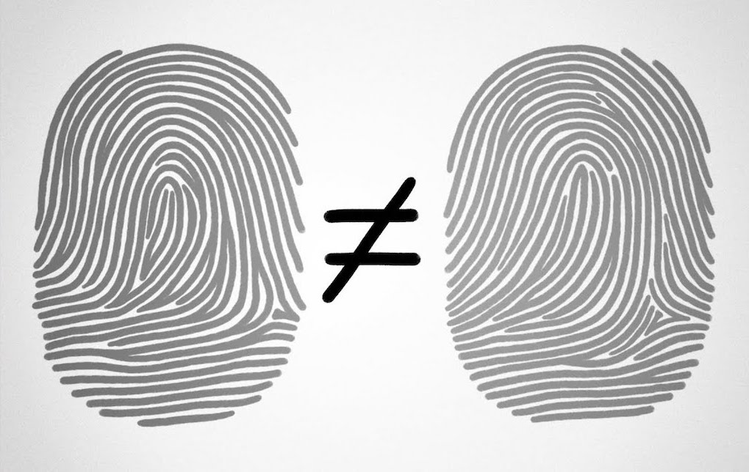
Picture 9) Pencil drawing of two distinct fingerprints.

The idea is that when a user registers in our application a request for bio-metric data is made. Then with the use of proper hardware, by pointing out to a file or with the use of eID, bio-metric data is uploaded to the database. One of the key design aspects of our dapp is that raw bio-metric data should never be uploaded to the application database, only an encrypted version should be kept. Even on the computer owned by the user sensitive bio-metric data should not be kept in the disk or in memory space. After registering, when prompted to authenticate (log-in), the user could use the same method again.
By not saving the sensitive data anywhere if the computer is compromised it becomes more difficult for the hacker to steal the credentials because because he/she wouldn’t be able to find them; of equal importance is to make sure that the connection is as secure as possible at the moment of data transmission and that the hardware used to read biometrics does not contain malicious code. One factor authentication means using fingerprints (one or many) and two factor entails using fingerprints plus iris. A three factor would entail using other facial features popular with face recognition techniques.
Because bio-metric data is unique to each person it can be used to manage identities of the users in our dapp. However it is also fairly easy to fabricate fake but nevertheless valid bio-metrics. This means that if we employ only biometrical data as a way to authenticate users, that in itself provides some level of validation of personhood but fails to filter fake accounts made by a malicious agent pretending to be imaginary people or impersonating someone they’re not thus exploiting the system.
The difficulty with biometric devices is that each one does their own implementation and there are no standards in the industry (each device genereates a different hash for the same fingerprint)

Picture 10) Expensive CredenceID trident is a small commercial all-in-one
apparatus that reads fingerprints, facial features and eye iris.

From a security viewpoint even with all the protective measures already mentioned (bio-metrics, smart-card, hashing tables) put into place to guarantee the true identity of the users accessing the network there still exists the possibility of identity mismanagement by submission of multiple false registrations, known as the Sybil attack, or by stealing the credentials of a good user from an already compromised device. After all smart cards are issued by a central authority and bio-metric data that is seemingly “valid” can also be fabricated as we’ve said. Pipes and ports are invariably fallible points on the data flow in software in most OS if not properly configured. In a worst case scenario a hacker with root access to another user’s system may have the dapp’s UI manipulated tricking the honest user into thinking that the application is secured and running as supposed while in fact sensitive data is being leaked in the background which can be particularly harmful when providing credentials. Developers can save themselves from falling into these traps by avoiding fragmenting the application into too many components, by consistently writing software documentation and code annotation in order to facilitate future audits and by loosely coupling the frontend to other processes and network channels while at the same time making sure that the application is running in a trusted execution environment.
In general in informatics no matter the level of defence there are always back doors in the system to be exploited. The cybersecurity community is well aware of these vulnerabilities and so we mention in suggested readings a collection of relevant scientific papers. What we want is to make sure that these doors are locked and only open when with intended.
Short; although anyone can lie about their identity pretending to be someone else, one can only fool so many people in a specific space over a short period of time before starting to spread alarm. This is valid in the on-line as well in the off-line world. Understanding the subtleties between on-line and out-of-band communication is thus crucial to the development of a sound identity management system.
Under strict conditions, for example by restricting conducting user verification by members of an ethical coordination group assigned by the on-line platform, we may prompt suspicious users to to do a 1-factor biometric authentication in a different hardware device (the ethical member’s for instance) in order to evaluate identity. A positive result is expected and thus shouldn’t be seen as special. However, a negative match between the proclaimed identity and the credentials provided is a strong indicator of malicious behaviour. User verifications that are conducted in this manner shouldn’t be mandatory however, the user should be given the option to refuse them because they involve trusting another party with some of your biometric credentials. Refusal, although not a strong indicator of misbehaviour should be signalled in the on-line platform as suspicious and be reason enough to lower the reputation of a user as will be explored in more detail in its own chapter.
Preventing network overtake by a group of bad actors in theory can be implemented by either exploring the fabric of social human relationships and interactions such as by implementing a reputation system or by exploiting the fact that a bad agent cannot be physically present at multiple distinct physical places at the same time.
A reputation mechanism is an undesirable scenario because it introduces a very subjective measure to a very objective problem as it needs to adjust the users level of trust of each other in order to judge their true identity. However it is a reasonable way to exploit human relations in order to provide information about the users while at the same time creating a barrier of entry that allows some level of control that otherwise might not exist.
Alternatively we may try to establish a one-to-one correspondence between virtual and real identities and force situations (pseudonymous parties) that would allow us to compare between on-line and human presence and look for a mismatch. Most of the techniques that take advantage of this are categorized as crowd-sensing and rely mostly on the analysis of the network topology (packet propagation, RSSI, IP/MAC address, network footprint, anonymous GPS tracking, etc.).
To achieve effective protection against false registrations techniques need to draw from all these separate approaches and involve out-of-band communication between the trusted and the suspicious users of the network. This can be achieved during political party events but there are also recent proposals designed with extra complexity that involve forms of gamification that take advantage of augmented reality features and smartphones.
The suggestion we make in this document is to not neglect any proposition and we encourage the developers to include as many techniques as possible for a final product and to explore new social gamification ideas.
Lastly, we wonder if the problem of protection against Sybil identities is in some way equivalent to solving a social deduction game with AI.

Suggested readings:

“A Universal Resolver for self-sovereign identifiers” entry on Medium, https://medium.com/decentralized-identity/a-universal-resolver-for-self-sovereign-identifiers-48e6b4a5cc3c

“You are surprisingly likely to have a living doppelganger” article by BBC,
https://www.bbc.com/future/article/20160712-you-are-surprisingly-likely-to-have-a-living-doppelganger

“On The Uniqueness of Fingerprints”, Anil K. Jain, Dept. Of Computer Science and Engineering, Michigan State University, http://biometrics.cse.msu.edu/Presentations/AnilJain_UniquenessOfFingerprints_NAS05.pdf

“Fake fingerprints can imitate real ones in biometric systems”, in The Guardian,
https://www.theguardian.com/technology/2018/nov/15/fake-fingerprints-can-imitate-real-fingerprints-in-biometric-systems-research

“DeepMasterPrints: Generating MasterPrints for Dictionary Attacks via Latent Variable Evolution” by Philip Bontrager et al, United States of America,
https://arxiv.org/pdf/1705.07386.pdf

Trident, a portable multiple feature biometric reader by CredenceID,
https://credenceid.com/trident/

Private biometrics entry on Wikipedia,
https://en.wikipedia.org/wiki/Private_biometrics

Smart card entry on Wikipedia,
https://en.wikipedia.org/wiki/Smart_card

OpenSC (Open source smart card tools and middleware), https://github.com/OpenSC

List of national identity card policies by country entry on Wikipedia,
https://en.m.wikipedia.org/wiki/List_of_national_identity_card_policies_by_country#Identity_card_policies_by_country

“Remote e-voting overview” by , sdadsad

“Social deduction game” entry on Wikipedia, https://en.wikipedia.org/wiki/Social_deduction_game

“Emergent bluffing and inference with Monte Carlo Tree Search”, Peter I. Cowling, Daniel Whitehouse and Edward J. Powley, UK, http://orangehelicopter.com/academic/papers/cig15.pdf

“Monte-Carlo Planning in Large POMDPs”, David Silver and Joel Veness, https://papers.nips.cc/paper/4031-monte-carlo-planning-in-large-pomdps.pdf

Direct Anonymous Attestation entry on Wikipedia,
https://en.wikipedia.org/wiki/Direct_Anonymous_Attestation

“What is Zero-Knowledge Proof?” entry on Deqode by Mrunal Kalband.
https://deqode.com/blog/what-is-zero-knowledge-proof/

“Zero-knowledge proofs of identity” by Amos Fiat et al., The Weizmann Institute of Science, Israel, 1988.
https://www.researchgate.net/publication/225604161_Zero-knowledge_proofs_of_identity

“Zero-Knowledge Proofs in M2M Communication” by Michael Schukat and Padraig Flood, NUI Galway, Ireland, 25th IET Irish Signals & Systems Conference, 2014.
http://www.osna-solutions.com/wp-content/uploads/ZKP-in-M2M-Communication-Paper.pdf

“Towards Anonymous, Unlinkable, and Confidential Transactions in Blockchain” by Kalpana Singh et al., IEEE Blockchain, Halifax, Canada, 2018.
https://hal.archives-ouvertes.fr/hal-01812004/document

“Zero-Knowledge Proof-of-Identity: Sybil-Resistant, Anonymous Authentication on Permissionless Blockchains and Incentive Compatible, Strictly Dominant Cryptocurrencies” by David Cerezo Sánchez, 2020.
https://eprint.iacr.org/2019/546.pdf

“A zero-knowledge-proof-based digital identity management scheme in blockchain” by Xiaohui Yang and Wenjie Li, Hebei University, China, 2020.
https://www.sciencedirect.com/science/article/pii/S0167404820303230

Semaphore, https://github.com/appliedzkp/semaphore

Reputation

A reputation system is desirable and necessary when there is mistrust on a central authority (mistrust in governmental issued smart-cards, public contracts, etc.). For a society that is not plagued by corruption where there is perceived trust a reputation mechanism is actually undesired because of its inherent subjectivity (utopic).
Reputation is evaluated when a user refers to another user as trustworthy. In general reputation is something that is built over time and involves human relationships. A properly designed reputation system should thus take advantage of socio-psychological factors. For a user to be considered trustworthy we might require for example that a user reports positively on another user. Likewise a negative reputation can be built and might be used to measure the intentionality of a user although this negative use of reputation should be avoided in order to protect minorities from mob judgement.
A fact to be exploited is that malicious agents tend to form separate clusters from good agents; malicious users will declare trust with other malicious users and have difficulty penetrating deep into the good user cluster. Random walks through the user base can be used to outline these groups and some techniques are proposed in the suggested readings.
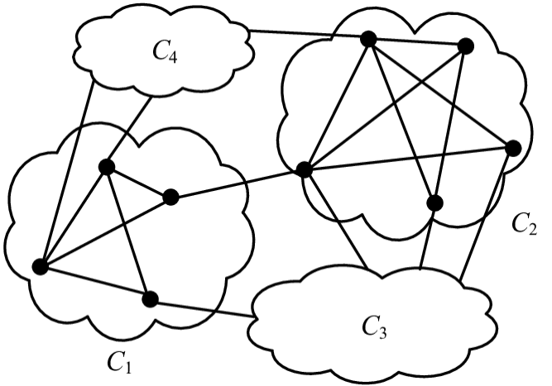
Picture 12) A trust social network is split into different clusters (or clubs).
WoT = Web of Trust
Another technique is to add a barrier to user registration. Demanding a referral at the process of registration is useful to prevent bad agents from creating multiple accounts two-ways:
By having a graph of the user trust relationships imposed by demanding an invitation we can track misbehaviour (at the same time this information should be used with a pinch of salt in order to not penalize situations where Sybil attacks are launched from hi-jacked user accounts). If a Sybil attack is traced back to an unsuspicious account the (supposedly) good agent can be alerted automatically by the system and be invited to change credentials and hardware. Failure to do so in a timely manner could be reason enough to lower the reputation of someone. This idea has already been implemented by BrightID.
In addition to imposing a social trust graph that later can be used as a form of traceability, a registration barrier is interesting because it limits exponential growth of Sybil identities; the idea is that new users cannot register on the on-line platform without inserting a passphrase (or similarly by reading a QR code from an already registered user). Starting with a small trusted group of say 100 users, secret passphrases are automatically generated for each user. By giving away these secret passphrases new users may register in the platform. Once used, the passphrases become invalid and the new users are not immediately given new passphrases. Also the passphrases should expire meaning that if they are not used during an iteration round then they cannot be accumulated and are erased. Then after a chosen period of time, all the users, new and old, are given a new invitation passphrase. So after a first iteration, 100 new users are at most added to the platform making a total of 200. After 16 iterations the user base should be 6 553 600 at most. For each malicious user from the initial trust group that would use the passphrase to create for himself multiple accounts would benefit at most from having 65 536 siblings at the end of 16 iterations, which represents 1% of the total of the user base. While this is still a considerably high number, it does represent an upper limit to how many siblings a malicious user from the initial group could create which otherwise would be unlimited. If the initial trust group is made to be a 1000 instead, then a malicious actor would hold at most 0,1% of all accounts when reaching 6 553 60 users which is even a lower bound. After a pre-configured number of iterations, or by reaching a predefined maximum number of users, the invitation process can be set to stop and the user base locked which further prevents Sybil identities from joining the network.
As a side note we remark that to know the residential address of a user is of importance for it might be used to block users from a specific jurisdiction to decide over matters that are not specific to that jurisdiction (i.e. someone living in the California state voting on polls created to address issues specific to New York state). Filtering age is also important to prevent users younger than 18 (or 21) years old from voting. This type of information is hard to confirm without the support of a central authority but can be validated by trusted peers. Whatever the implementation, the reputation mechanism must be flexible enough to allow people to change residency and still not be heavily penalized for doing so.
There maybe multiple ways to build reputation; by introducing new members to the network or just by the simple passage of time or even by allowing interaction with external user databases that are deemed trustworthy, for example. Likewise we might think of multiple ways to lose reputation; but unlike positive build up we should restrict negative reputation to computer algorithms as much as possible. This is to minimize situations where the “rule is by the mob” and be as impartial as possible.
When the reputation of a user reaches a specified low threshold different consequences may be put to action from temporarily forbidding the user from voting on polls to a permanent ban from the network altogether. Forms of litigation to account for unfair decisions are important.
Whatever identification and security measures we may choose to implement to protect our system we must always keep in mind that it is the nature of software that there will always be open ends. What we want here is to make sure that the effort to manipulate the system is so difficult and costly from a human resources perspective that the advantages that an actor might hope to gain from exploiting the software architecture are at most the same as using the system itself in a legit way. That is to say someone with egoistic intentions looking to take advantage of politics and the electronic vote for personal gains would find it actually easier to use political argumentation and propaganda than hacking the informatic system (social engineering). At this point we can say that even though the informatic system has flaws it can be considered secure enough to be used. This argument implies the necessity of considering the unknown dangers and prospects of bad actors “hacking” the human mind instead of the computer network. In this sense, and drawing from experience from popular social networks, we consider using the results found in “Detecting "Smart" Spammers on Social Network: A Topic Model Approach“ mentioned in the suggested readings. To at least automatically decrease the reputation of a user using this technique might be interesting to consider.

Suggested readings:

“Three and a half degrees of separation”, Smriti B. et al, Facebook, 2016,
https://research.fb.com/blog/2016/02/three-and-a-half-degrees-of-separation/

“Learning to Trust Strangers” by Martti Malmi, 2015, on Medium,
https://mmalmi.medium.com/learning-to-trust-strangers-167b652a654f

“Sybil-resistant trust mechanisms in distributed systems”, Pim Otte, Delft University of Technology, Delft, Netherlands, 2016,
https://repository.tudelft.nl/islandora/object/uuid:17adc7bd-5c82-4ad5-b1c8-a8b85b23db1f/datastream/OBJ/download

“A Robust Distributed Reputation Mechanism for Peer-to-Peer Systems”, Rahim Delaviz Aghbolagh, Kungliga Tekniska Hogskolan, Stockholm, Sweden, 2013,
https://repository.tudelft.nl/islandora/object/uuid:a4420421-1092-44b8-9016-c80d506252d3/datastream/OBJ/download

“SoK: The Evolution of Sybil Defense via Social Networks”, Lorenzo Alvisi et al,
http://www.cs.cornell.edu/lorenzo/papers/Alvisi13SoK.pdf

“ReCon: Sybil-Resistant Consensus from Reputation”, Alex Biryukov and Daniel Feher, University of Luxembourg, Luxembourg, 2020,
https://orbilu.uni.lu/bitstream/10993/41325/1/biryukov-feher-recon.pdf

“Smart contracts for blockchain-based reputation systems: A systematic literature review” by Ahmed S.Almasoud et al, 2020, https://www.sciencedirect.com/science/article/pii/S108480452030285X

“Detecting "Smart" Spammers on Social Network: A Topic Model Approach”, anonymous contribution, https://www.researchgate.net/publication/305334285_Detecting_Smart_Spammers_On_Social_Network_A_Topic_Model_Approach/link/5e102b80a6fdcc28375638bb/download
https://explorer.brightid.org/

BrightID, https://github.com/BrightID/BrightID-AntiSybil

“Pseudonym Parties: An Offline Foundation for Online Accountability” by Bryan Ford, Massachusetts Institute of Technology, USA, 2007,
https://bford.info/log/2007/0327-PseudonymParties.pdf

“First Encointer ceremony bootstrapping local currency in Zurich”, 2020, https://youtu.be/tcgpCCYBqko

https://en.wikipedia.org/wiki/Contact_tracing#Mobile_phones

https://en.wikipedia.org/wiki/Digital_contact_tracing

https://f.hubspotusercontent30.net/hubfs/7663287/covid_watch_whitepaper.pdf

Trust

Define web-of-trust and its improvement or difficulties vs traditional pki

present voteAgain?

Suggested readings:

“A Decentralized Dynamic PKI based on Blockchain” by Mohsen Toorani and Christian Gehrmann, Lund University, Sweden, 2020.
https://arxiv.org/abs/2012.15351v1

“Coercion-Resistant Voting in Linear Time via Fully Homomorphic Encryption: Towards a Quantum-Safe Scheme” by Peter B. Rønne et al., Financial Cryptography and Data Security, 2019. https://arxiv.org/abs/1901.02560

“VoteAgain: A scalable coercion-resistant voting system” by Wouter Lueks et al., 29th USENIX Security Symposium, 2020. https://arxiv.org/abs/2005.11189

VoteAgain, https://github.com/spring-epfl/voteagain

Mitigation

In this chapter we assume that a bad actor successfully compromised the network and holds a considerable percentage of the user base accounts. We study how can we detect such situations and lessen the damage caused in a timely manner.
The most obvious indicator of significant presence of fake accounts in a political Dao would be when the number of active participants on a particular event far exceeds the expected (announced) maxima. Say a village has a population of 10 000 people where everybody is participating in the Dao and 12 000 users are showed to vote on-line. Obviously there are 2 000 fake accounts present in the system. This actually happens in real life with traditional voting methods as can be seen on “A sampling of election fraud cases across the country” paper under false registrations category (link found on suggested readings on the chapter Electronic Vote). An obvious solution to differentiate fake accounts from real ones is to invite all users of the Dao and reserve a specific day to conduct exhaustive user verification. Although this may work in theory it is logistically impractical. Also, counting the number of people present in a crowd in a more aggregate sense (without accessing each member individually) can effectively identify if a Sybil is present amongst a group of people in some circumstances but does not provide a method for identification of the originator of the attack and for small crowds it does not work because unknown bad agents can be present at the moment of counting. For example assume that a given number of people are present at one location (during a pseudonymous party, a political event, i.e. a congress). An estimation is made on the number of people that are really there by some counting method and a prompt is made to each user through the dapp asking whether they are really present or not. Mismatch between the observed participants and the number of users signalled to be present at the event is an indicator of Sybil presence. However if the number of absent good actors is significant then the presence of Sybil identities can be masked by the appearance of bad agents on site. The probability of this happening without anyone noticing is higher for small and medium sized crowds evidently.
The question then remains how to single out the bad actors who are trying to cheat the system. It may even be the case that the original attacker may not be physically present at a particular political event but with the right techniques we may catch some of the fake accounts and black list them:
One way to achieve this is by tracking RSSI propagation such as by using bluetooth signals through a crowd (crowd-sensing) of users who own a smartphone capable of authentication by fingerprint readings. Because bluetooth is a low frequency electromagnetic wave its propagation remains confined to small areas of about ? square meters from each emitter and studies have shown accuracy of up to 1,5m which is sufficient for our goals. By analysing the time of propagation between sources in the RSSI space and by comparing the identities of the agents declared in the virtual space, that is to say signalled in the on-line platform for political discussion, we can automatically infer Sybil identities without requiring any human input. This procedure is in theory efficient but in practice depends on the network topology and hardware specificities; also on the size and background noise in a given environment during pseudonymous parties. Details of possible implementations were studied by Jianliang Wu et al with a technique named Blueshield that is referenced in the suggested readings further below. Also a paper entitled “An RSSI-based Scheme for Sybil Attack Detection in Wireless Sensor Networks“ by Murat Demirbas et Youngwhan Song claims detection with 100% completeness with less than a few percent false positives by using bluetooth RSSI positioning and triangulation.
Another technique that can and should be used parallel to the one mentioned above and that is not limited to pseudonymous parties is using anonymous GPS tracking. Geographic Information Systems coupled with GPS tracking are already largely implemented in most modern smartphones and allow real-time spatial navigation by geo-locating the user. This same technology can be used to investigate if a user is present in a given geographical area or not. (margin of error?). In addition to GPS, Wi-Fi access points can also be used to assert user geo-location. This information allows then for the creation of an anonymous roadmap of the user movements over time. We can then through an algorithm evaluate where was a user located in a specific time period. If anonymous-preserving roadmaps precisely and constantly match between two different users then we have sufficient reason to consider a case for multiple identities disguised under a single entity. Similar to this idea is comparing IP and MAC addresses for each user. A continuous match of these features for two different user accounts is also a strong indicator of Sybil identities. These kind of techniques are what the cybersecurity community calls network footprint analyses. Users who willingly submit their anonymous geospatial roadmaps should automatically see their reputation increased.
These techniques can be somewhat evaded in a situation where a group of malicious agents share and periodically swap between themselves hardware devices. We say somewhat because unless these swaps occur in a very synchronous fashion and the geospatial routes are carefully planned they will appear suspicious to the network. Again, all we’re taking advantage of is the fact that it’s physically impossible for a person to be present in two distinct locations.
To conclude; if we couple crowd-sensing which can be implemented with varying complexity and which relies on local spacial relations with network footprint analysis and anonymous GPS and GSM tracking (or hybrid architectures), which give more of a global overview on the geospatial disposition of the users and what devices they’re using we may be able to build a system hard to exploit.
There’s a third vertice to this mitigation triangle which we can identify as out-of-band communication or gamification techniques. These are security procedures that are specifically designed to require human interaction by prompting the user for input that in principle is impossible to be correctly asserted by an algorithm or without a human being physically present at a specific place and time. These can range from prompting the user to scan a QR code screened on a particular display on public space to prompting the user for secret passphrases generated by other users that can be exchanged during phone calls (for example) and that are assumed to never be exposed publicly. A little imagination is necessary but many different approaches can be envisioned; the key idea is to find a mechanism that uses out-of-band communication between users of the network that is impossible to be mimicked by artificial means alone.
Although not a cybersecurity feature in of itself, requiring a public profile photo may be useful in alerting the community when an agent is pretending to pose as someone else for obvious reasons. A photoblog of small pseudonymous parties can likewise be valuable .. Facial recognition may be employed for automating these
Protection against the Sybil vulnerability is also somewhat akin to solving a social deduction game with artificial intelligence. We know that ML has already solved all open board games only remaining hidden information games which is a remarkable modern achievement. The analogy between the traditional werewolf card game for example and our dapp design is that the werewolves are equivalent to the bad actors and villagers are honest users (in the traditional game werewolves are posing as villagers while secretly holding werewolf cards). Hypothetically a way to solve this is by cheating; forcing all players to reveal their cards at the same time ending the game and effectively making the werewolves identities known. In practice however this is currently being studied by constantly inferring and testing the hypothesis and rebuilding the ML model.
Again, while many different techniques have been proposed to reduce the impact of Sybil attacks in Daos by using crowd-sensing during pseudonymous parties, by analysing network footprints, anonymously tracking user geolocation and making use of out-of-band communication, there is no simple solution; complete protection against Sybil attacks must draw features from social interactions at large and use forms of social gamification and are a subject of active study.
Because a small percentage of Sybil identities is always expected to be present it maybe useful to require a consensus higher than 50% to validate policies, for example, by requiring at least 60% consensus.

Suggested readings:

"Managing Sybil identities in distributed networks", Athichart Tangpong, Pennsylvania State University, Pennsylvania, USA, 2010,
https://etda.libraries.psu.edu/files/final_submissions/551

“Proposal for Self-Registration” by Jochen Dinger and Hannes Hartenstein, Institut fur Telematik, Universit¨at Karlsruhe, Germany, http://web.mit.edu/golem/working/bootstrap-graph/related/sybil-taxonomy.pdf

“Blockchain-based Sybil Attack Mitigation: A Case Study of the I2P Network”, Kotaiba Alachkar and Dirk Gaastra, University of Amsterdam, Netherlands, 2018,
https://delaat.net/rp/2017-2018/p97/report.pdf

Privacy, security, and data integrity in Crowdsensing, https://en.wikipedia.org/wiki/Crowdsensing#Privacy,_security,_and_data_integrity

“Blockchain-based Crowd-sensing System”, Junqin Huang, Shanghai Key Laboratory of Scalable Computing and Systems, Shanghai Jiao Tong University, China, 2018,
http://huangjunqin.com/papers/HuangHotICN2018Blockchain.pdf

“Accurate Sybil Attack Detection Based on Fine-Grained Physical Channel Information”, Chundong Wang et al, journal Sensors, 2018,
https://www.ncbi.nlm.nih.gov/pmc/articles/PMC5877424/pdf/sensors-18-00878.pdf

“BlueShield: Detecting Spoofing Attacks in Bluetooth Low Energy Networks”, Jianliang Wu et al, Purdue University, Indiana, USA,
https://www.cs.purdue.edu/homes/dxu/pubs/RAID20-BlueShield.pdf

“Privacy Preserving and Cost Optimal Mobile Crowdsensing using Smart Contracts on Blockchain”, Dimitris Chatzopoulos et al, University of Helsinki, Helsinki, Finland, 2018, https://arxiv.org/abs/1808.04056

“SybilEye: Observer-Assisted Privacy-Preserving Sybil Attack Detection on Mobile Crowdsensing”, Junhyeok Yun and Mihui Kim, South Korea, 2020,
https://www.mdpi.com/2078-2489/11/4/198

“A privacy-preserving collaborative reputation system for mobile crowdsensing”, Bayan Hashr Alamri et al, International Journal of Distributed Sensor Networks, 2018, https://journals.sagepub.com/doi/pdf/10.1177/1550147718802189

“Secure multiparty aggregation with differential privacy: A comparative study” by Li Xiong et al., Emory University, USA, Proceedings of the Joint EDBT, 2013.
http://www.mathcs.emory.edu/aims/pub/goryczka13pais.pdf

“Differentially Private Mobile Crowd Sensing Considering Sensing Errors” by Yuichi Sei et al., University of Electro-Communications, Tokyo, Japan, 2020.
https://www.mdpi.com/1424-8220/20/10/2785

“Where You Are Is Who You Are: User Identification by Matching Statistics”, Farid M. Naini et al, IEEE, 2015, https://arxiv.org/pdf/1512.02896v1.pdf

“Unique in the Crowd: The privacy bounds of human mobility”, Yves-Alexandre de Montjoye1 et al, Massachusetts Institute of Technology, Harvard University, Center for International Development, Université Catholique de Louvain, 2013, https://www.nature.com/articles/srep01376.pdf

“Tailoring Onion Routing to the Internet of Things: Security and Privacy in Untrusted Environments” by Jens Hiller et al, 27th IEEE International Conference on Network Protocols (ICNP), 2019.
https://www.comsys.rwth-aachen.de/fileadmin/papers/2019/2019-hiller-tailoring.pdf

“Who Watches the Watchmen? A Review of Subjective Approaches for Sybil-resistance in Proof of Personhood Protocols” by Divya Siddarth et al, https://arxiv.org/abs/2008.05300

Cryptographic primitives

Public-key Infrastructure (digital certificates, SSL)

Zero-Knowledge (private voting)

homomorphic encryption (bulletin-board)

Suggested readings:

“Secure Hash Standard”, National Institute of Standards and Technology,USA 2015,
https://nvlpubs.nist.gov/nistpubs/FIPS/NIST.FIPS.180-4.pdf

“Homomorphic Encryption Standard” by Martin Albrecht et al., Homomorphic Encryption Standardization Workshop, Washington, USA, 2017.
https://projects.csail.mit.edu/HEWorkshop/HomomorphicEncryptionStandard2018.pdf

“Fully Homomorphic NIZK and NIWI Proofs” by Prabhanjan Ananth et al.,
https://eprint.iacr.org/2019/732.pdf overkill?

https://github.com/mukeshtiwari/SchulzeHomomorphicCounting

https://github.com/smlbarnes/Blockchain-Ballot

DID

Decentralised ID “standard” – interoperability, universality,

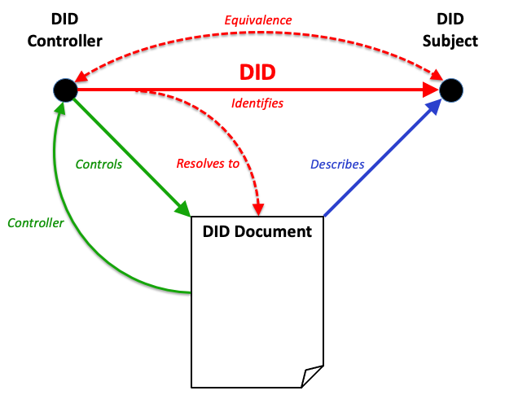

Figure 2 “A DID is an identifier assigned by a DID controller to identify a DID subject and resolve to a DID document that describes the DID subject. The DID document is an artifact of DID resolution and not a separate resource distinct from the DID subject.”

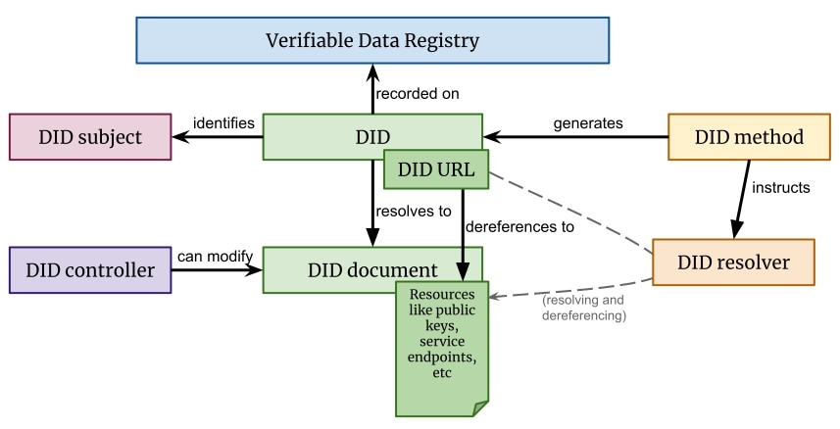
Figure 1 The basic components of DID architecture

Suggested readings:

“An introduction to decentralized identities” by Microsoft,
https://www.youtube.com/watch?t=675&v=r28GeXkxn0w&feature=youtu.be

“Decentralised Identity: What’s at Stake?” paper by Kai W. et al, INATBA, 2020,
https://inatba.org/wp-content/uploads/2020/11/2020-11-INATBA-Decentralised-Identity-001.pdf

“Decentralized Identifiers (DIDs): Core architecture, data model, and representations” by the World Wide Web Consortium, https://w3c.github.io/did-core/

“Decentralized identifiers (DIDs) fundamentals and deep dive”, Markus Sabadello and Drummond Reed during SSI Meetup, 2020,
https://www.youtube.com/watch?v=SHuRRaOBMz4

“CanDID: Can-Do Decentralized Identity with Legacy Compatibility, Sybil-Resistance, and Accountability”, Deepak Maram et al, 2020,
https://eprint.iacr.org/2020/934.pdf, https://github.com/canonical/candid

https://www.youtube.com/watch?v=B3mhWCp5itk
https://www.youtube.com/watch?v=m1QkulPTxBY

“Understanding Decentralized Identity” on The Control by Richard Chen,
https://thecontrol.co/understanding-decentralized-identity-433abb343279?gi=d0d75e927ca1

“The DID Dilemma: When is an identifier ‘decentralized’?” on Medium by Markus Sabadello et al, Decentralized Identity Foundation, Jun 5, 2019,
https://medium.com/@decentralized.identity/the-did-dilemma-when-is-an-identifier-decentralized-9c2c68433b67

“A Decentralized Dynamic PKI based on Blockchain” by Mohsen Toorani and Christian Gehrmann, Lund University, Sweden, 2020.
https://arxiv.org/abs/2012.15351v1

FIDO2

Suggested readings:

https://fidoalliance.org/fido2/

https://en.wikipedia.org/wiki/WebAuthn

https://en.wikipedia.org/wiki/Client_to_Authenticator_Protocol
https://www.trustkeysolutions.com/press/pr2/

Quantum crypto


Picture 13) Quantum computer; Credit Volker Steger/SPL.

Suggested readings:
https://www.theqrl.org/blog/enqlave-the-quantum-safe-for-your-crypto-assets/

Article “What is Quantum Computing?” from Indian enterprise OodlesTechnologies, https://blockchain.oodles.io/blog/quantum-computing-develop-smart-contract

Forbes on “Quantum Computing Poses An Existential Security Threat, But Not Today”, https://www.forbes.com/sites/waynerash/2019/10/31/quantum-computing-poses-an-existential-security-threat-but-not-today/#5af86a125939

American Scientist on “Is Quantum Computing a Cybersecurity Threat?”, www.americanscientist.org/article/is-quantum-computing-a-cybersecurity-threat

“Quantum computers put blockchain security at risk” by science magazine Nature, https://www.nature.com/articles/d41586-018-07449-z

“qBitcoin: A Way of Making Bitcoin Quantum-Computer Proof?” By Mark Anderson, https://spectrum.ieee.org/tech-talk/computing/networks/qbitcoin-making-bitcoin-quantumcomputer-proof

“Algorand Contributes to 4 Post-Quantum Standards Entering the 2nd Round of National Institute of Standards and Technology Competition” by Sergey Gorbunov,
https://www.algorand.com/resources/blog/algorand-contributes-to-4-post-quantum-standards-entering/
System versions

There are many different display sizes and hardware interfaces to explore; smartphone, pad, laptop, desktop, projector and even futuristic systems such as virtual reality technologies have become mature enough that we can consider their use. We discuss these possibilities but focus on the regular smartphone plus desktop approach. Desktops are better in comparison not only in screen size but also at the hardware level and in general have better internet connection. This allows for more data to be displayed at once and …
On the other hand smartphones are widely adopted and are more portable than other devices and this is an advantage that is worth considering, for example, by using it as a voting controller in restricted situations. Another positive note is that it is becoming more common to include fingerprint readers on smartphones. We can take advantage of this and use it as a means for authentication in our dapp. Using the smartphone as a voting controller is only encouraged during real life debate scenarios. It can also function as a receptor for notifications of dapp activity and as a geolocator for public institutions. We limit the ability to take input from the user and some of its functions have more options on the desktop version.
The MVP is thought up to have 6 different view pages; Wall, Profile, Institutions, Forum, Program and Debates. The smartphone MVP drops the Forum view because of screen size limitations (text readability is reduced):

- Public and private profiles. Multiple privacy-preserving settings; if the user wants to hide as much information as possible then only the username (possibly the nickname?) should be public. No one from the platform or outside the platform should be able to track users activity, ie; who he/she delegated their votes, what was their recent votes on certain policies. Privacy preserving settings are not allowed for users who take public office.
- Social graph; this is a module where the user can see who he/she delegated the votes to and follow the web of social connections. This too can be set to private.
- Institutions; this view is used to present public institutions such as the Mayors Public Office building (USA). It should contain contact links, recent activity from public organs that are home to that institution as well as the composition of its members. The institution page can also be used to present Cores which are inner organs of political parties.
- Forum (bulletin-board text-based) where users can create new topics and publish policy proposals and attach necessary files. Topics can be run as polls and voted on. Encrypted private messaging between members on the forum and private chat-rooms as well as forum categories for special user groups that we name Core. In this same space some form of automated PDF file output for printed records of what happens in the dapp.
- Cores are groups of militants that work together for a common project. The forum should have a category for each core as well as encrypted chat-rooms. Cores are able to upload their own videos of their debates. They have their own Institution page with an extra public guest-book.
- Video streaming of debates; a special group of users should be able to cast live streams of political debates that occur during political parties activities. Also allow the upload of documents related to policy making.
- Hemicycle view. In this view the user is presented with a graphical representation of the constituents of a given political organ. The user should be able to scroll through this list and access each person’s profile individually.
- Eco-econometric report view.

Projector displays are also interesting for they allow an even bigger display size and thus a bigger audience interaction… allowing for group project presentations and decision making…
Virtual Reality systems ...
WHAT IS SYSTEM VERSIONS EXACTLY IN SOFTWARE DESIGN?

Smartphone

During political debates it’s useful to have the option to trigger a polling prompt across the smartphones of the participants in order to probe opinions. The smartphone version should also allow users to scroll through and visualize videos of party debates as well as browse through their history. Thirdly smartphones should present notifications of activity that happens on the desktop version that a user may want to follow up on the go.
Lying outside the MVP are augmented reality features. Fix my street is a known and successful example of integration of technology in politics. In its platform the users can signal to authorities damaged sections in public space by submitting an on-line form. One example of a possible integration of augmented reality with our dapp would be to create some sort of “augmented Fix my street” where we could signal to authorities damage in public space. This could be extended to signal pollution sites, environmental violations, illegal construction, etc…

Picture 14) Imagine the possibilities of A.G. and smartphones. In this case we are seeing someone using Google street view while being on the same street that is being visualized.

Also most forms of gamification that tackle the Sybil attack vulnerability rely on using the smartphone GPS tracking and AG.

Suggested readings:

FixMyStreet, https://www.fixmystreet.com/

“Proof of Witness Presence: Blockchain Consensus for Augmented Democracy in Smart Cities”, Evangelos Pournaras, aSchool of Computing, University of Leeds, Leeds, UK, 2020. https://arxiv.org/pdf/1907.00498.pdf

Open source SoC

The fundamental principle of cybersecurity as stated in the “before pages” of this document is the assumption that the attacker of a system has access to all the details of the same……….. and that the most advanced methods of obfuscation are eventually broken and that hiding components only adds a layer of uncertainty.

Suggested readings:

Risc-V, https://riscv.org/

What is Open Hardware?, https://opensource.com/resources/what-open-hardware

Open-source hardware, https://en.wikipedia.org/wiki/Open-source_hardware

Hardware-based full disk encryption entry on Wikipedia, https://en.wikipedia.org/wiki/Hardware-based_full_disk_encryption

“Board Farm APIs for Automated Testing of Embedded Linux” presentation by Tim Bird, Sony & Harish Bansal, Timesys, USA, 2020, https://youtu.be/ePYHuWyb0uk

List of suppliers of System on Chips,
https://en.wikipedia.org/wiki/List_of_system_on_a_chip_suppliers
https://youtu.be/CBec51Q1fSk
https://youtu.be/tDVWA3wdStY
https://libreda.org/
https://www.techrepublic.com/article/is-the-intel-management-engine-a-backdoor/
https://chips4makers.io/
https://en.wikipedia.org/wiki/Field-programmable_gate_array
https://en.wikipedia.org/wiki/Reconfigurable_computing
https://libre-soc.org/
https://en.wikipedia.org/wiki/Arduino
https://www.youtube.com/watch?v=CWW-GOjJRIE
https://en.wikipedia.org/wiki/Novena_%28computing_platform%29
https://media.ccc.de/v/36c3-10690-open_source_is_insufficient_to_solve_trust_problems_in_hardware#t=393
https://libresilicon.com/
https://github.com/open-sdr/openwifi

https://github.com/SpinalHDL

https://www.fossi-foundation.org/

https://github.com/efabless
https://www.cs.ucf.edu/~czou/research/Chipset%20Backdoor-AsiaCCS09.pdf
https://betrusted.io/

https://www.librecores.org/

http://fusesoc.net/

https://pypi.org/project/edalize/

TEE (Trusted Execution Environment)

TEE is enough to guarantee that you are using the intended software and that it has not been tampered by a third party… however it does not address the question whether the other nodes or peers on the network are also doing the same (running the intended software and nothing else):
to test this each node (peer) needs to hash its internal state and upload it to a common blockchain in order to compare the values. For this operation to be valid it should occur during a short time interval and with random “hash seeds” that are not shared between too many nodes NOT ENOUGH

Suggested readings:

Trusted Computing entry on Wikipedia, https://en.wikipedia.org/wiki/Trusted_Computing

“Operating System Support for Run-Time Security with a Trusted Execution Environment” by Javier González, University of Copenhagen, 2015.
https://core.ac.uk/download/pdf/50528559.pdf

https://security.stackexchange.com/questions/67003/loading-code-securely-in-the-trusted-execution-environment-arm

https://elinux.org/images/e/e6/OP-TEE-Using_TrustZone_to_Protect_Our_Own_Secrets-20171023-2.pdf

https://youtu.be/MREwcSo0uz4

“Confidential Computing Deep Dive” by The Confidential Computing Consortium, October, 2020, https://confidentialcomputing.io/wp-content/uploads/sites/85/2020/10/Confidential-Computing-Deep-Dive-white-paper.pdf

“Keystone: An Open Framework for Architecting Trusted Execution Environments” paper by Dayeol Lee et al, UC Berkeley, 2020, https://dl.acm.org/doi/pdf/10.1145/3342195.3387532

“Portable Implementation of GlobalPlatform API for TEE” presentation by Kenta Nakajima & Kuniyasu Suzaki from Technology Research Association of Secure IoT Edge Application Based on RISC-V Open Architecture (TRASIO), Japan, 2020,
https://www.youtube.com/watch?v=EIwgMUi7pTg

“ConsenSGX: Scaling Anonymous Communications Networks With Trusted Execution Environments” by Sajin Sasy and Ian Goldberg, Proceedings on Privacy Enhancing Technologies, 2019, https://petsymposium.org/2019/files/papers/issue3/popets-2019-0050.pdf

“Towards a standards-compliant pure-software Trusted Execution Environment for Resource-constrained Embedded Devices” by Hassaan Janjua et al.,Research Fund KU Leuven and by the imec High Impact Initiative Distributed Trust projec, 2019.
https://lirias.kuleuven.be/retrieve/551374

AMD Memory Guard, https://www.amd.com/system/files/documents/amd-memory-guard-white-paper.pdf

https://interfacemasters.com/products/nics/encryption-nics/

Root of Trust: https://www.intel.com/content/dam/www/public/us/en/documents/research/ilhan-gurel-attestation-challenges-and-gaps.pdf - https://keystone-enclave.org/files/keystone-risc-v-summit.pdf

Overlay network

VPNs must be no log = trusted service
Tor = trustless

Suggested readings:

https://sheharbano.com/assets/publications/coconut.pdf

“The Nym Network, The Next Generation of Privacy Infrastructure” by Claudia Diaz et al., Nym Technologies, 2021. https://nymtech.net/nym-whitepaper.pdf

https://www.orchid.com/how-it-works/ ??? duvido que funcione

Tallow, https://reqrypt.org/tallow.html

Orbot, https://guardianproject.info/apps/org.torproject.android/

Running environment

“Even though distrusting the servers is useful in ensuring robust protocol and system design, steps should still be
taken to make the servers more trustworthy. One way to do this is to minimize the number of components that
must be trusted; an example would be using servers that support unikernel architectures, as described in Sec-
tion 6.1.4, to ensure that there is little to no other potentially vulnerable software software, including OS libraries,
running alongside the E2E-VIV components.”
BANANABALLOT – Interl Management Engine is compromised?

AMD’s boot is better? What about TEE boot?

Talk about Tails

sandboxing: apparmor, bubblewarp = sandbox an entire app, libseccomp = add sandboxing features to your app

Suggested readings:

GrapheneOS, https://grapheneproject.io/

Qubes OS, https://www.qubes-os.org/

Unikraft, http://www.unikraft.org/

Tails, https://tails.boum.org/

“The Linux Foundation Launches ELISA Project Enabling Linux In Safety-Critical Systems”, 2019, https://www.linuxfoundation.org/en/press-release/the-linux-foundation-launches-elisa-project-enabling-linux-in-safety-critical-systems/

AppArmor, https://www.apparmor.net/

BubbleWrap, https://github.com/containers/bubblewrap

libseccomp, https://github.com/seccomp/libseccomp

https://github.com/selinuxproject

Dependencies

It should be noted that only Java, Javascript, ? fully support all of the libraries mentioned below. These are the essential suggested software APIs/frameworks/libraries for the MVP:

Blockchain technologies:
Algorand, www.algorand.com
link to SDK
Interplanetary File System, www.?.com
link to SDK
Authentication services:
Credence, www.?.com (is this sdk open source?)
https://github.com/CredenceID/Credence-ID-DeviceSDK-Jar
Encryption:
Strong encryption hashing functions,
link
Secure HTTPS connections, (how can we reinforce the security of a connection?)
link
TEE
link
QR CODE API, www.?.com
link to SDK
WebRTC:
Matrix
link
JITSI?, www.?.com
link to SDK
Full product extra frameworks:

Chainlink, www.?.com
link to SDK

Augmented reality SDK for smartphones,
link to SDK

GIS API,
link

MAGI stack

mention CEVN? : cockroachdb+electron+vue+node for centralized frontend

mention Skynet as alternative to IPFS! Skynet uses PoW which is a downside but does IPFS even have a consensus mechanism?

Suggested readings:

Distributed Application Starter: Vue front-end, Ethereum / IPFS Backend, https://github.com/redacademy/vue-ethereum-ipfs

Modules

Suggestion is made to follow MVC pattern with modules as follows:

Backend modules:

- Authentication.

- Crowd-sensing.

- Reputation.

- Gamification.

- Chat-room.

- Forum (bulletin board).

Frontend modules:

- WebRTC.

- Social graph.

- Hemicycle.

- Institutions / profile / wall / debate views.

- Electoral program editor.

Data model

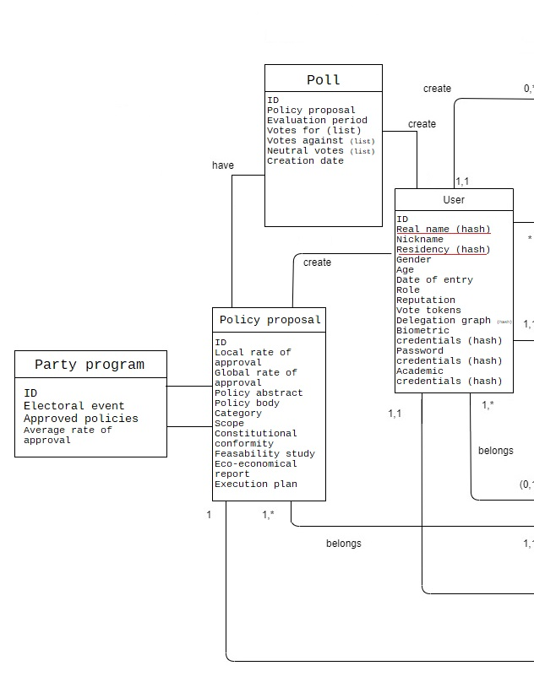

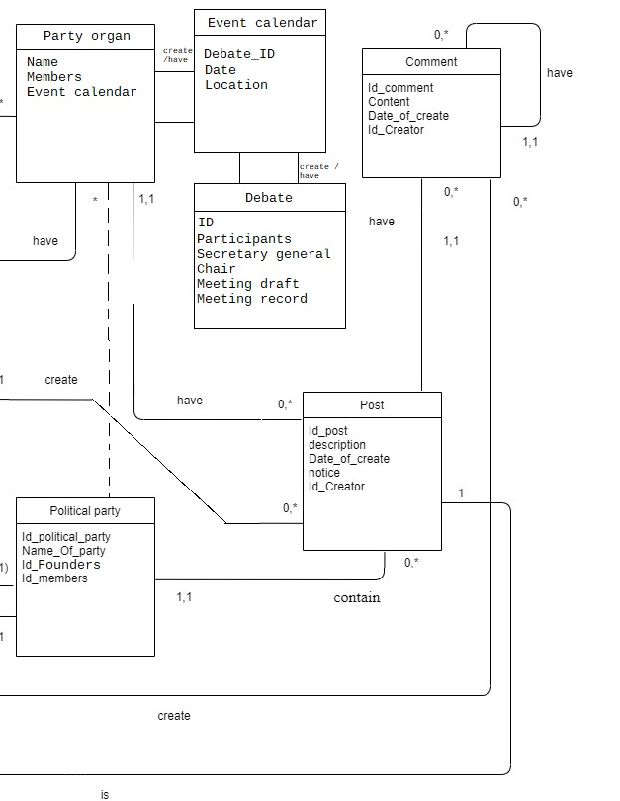

State diagram

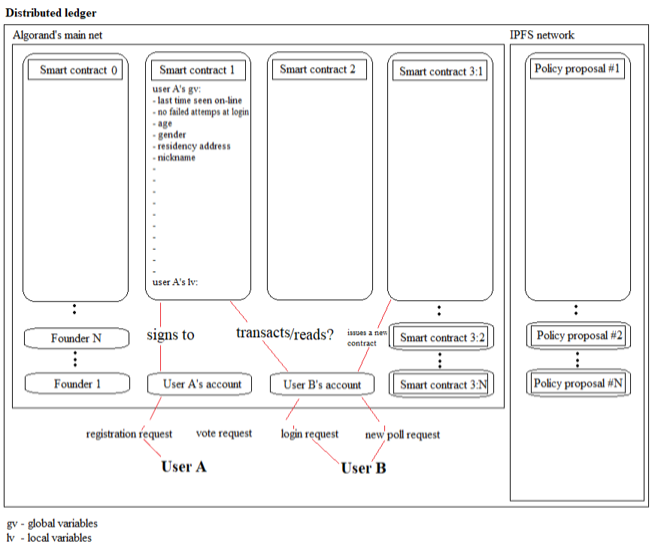
Diagram 2) State diagram for the dapp-blockchain interaction.

Ideally all the dapp’s functions including forum posts, comments, images, etc. should be stored and secured on-chain. But for simplification of the problem at hand and for a first MVP, the state diagram we present here focuses only on the most essential aspects of IM and policy submission and subsequent voting.

Smart-contract 0 is the contract made between the “founders” of the dapp where the initial passphrases are generated and distributed. Also functions as a passphrase generator for new users that register in the platform in combination with smart-contract 1.

Smart-contract 1 functions as a store for hashed bio-metrics and guarantees that the same fingerprint is not used to create more than one account. Additionally it’s used to verify authenticity of users when they log in.

Smart-contract 2 are special contracts issued when doing crowd-sensing to detect Sybil identities during political party events. In order to fully participate in these events users need to sign a contract attesting that they were physically present at the location where the event took place. Crowd-sensing techniques are applied to verify the claim. The result is then stored on-chain for later analysis.

Smart-contract 3 are a collection of smart-contracts that are issued each time a user publishes a new policy in our dapp. It’s also called every time a poll is run to evaluate political consensus.

Authentication

A fundamental component of our authentication system is bio-metric data. This data can come from three different sources; fingerprints, iris and facial features. We also make use of traditional authentication methods such as password and e-mail verification. An e-mail is sent to the user to confirm its ownership. Also it might be interesting to consider phone number verification. Some countries have strict regulations as regards to phone number attribution that we can exploit such as in Brazil or in Algeria. Lastly we’ll make optional use of smart cards issued by governmental entities wherever possible:

 | LEVEL 0 | LEVEL 0.5 | LEVEL 1 | LEVEL 1.5 | LEVEL 2
E-mail & password | x | x | x | x | X
Single fingerprint |  | x
Phone number |  | x
Referral
Governmental  issued smart-card |  |  | Optional | Optional | Optional
Double fingerprint |  |  | x | x | x
Iris |  |  |  | x | x
Facial features |  |  |  |  | x
Table 1) Authentication table.

At 0.5 in addition to a single fingerprint we also require the introduction of a code sent by SMS to a phone number because at 0.5 the idea is to allow the user to use the smartphone to cast votes when the user is present during debates. Access to forum, program and full wall features with the desktop is still denied at 0.5. At level 1 the user is authorized to access the dapp without voting permissions unless the optional eID is presented. From 1.5 to level 2 full dapp access is given without any restrictions. The use of eID should be supported but not mandatory and must not be used as a substitute for fingerprint input.
The user can opt at the profile settings to allow only for authentication with level 2 credentials or with mandatory use of eID, for extra security.

Suggested readings:

“Blockchain meets Biometrics: Concepts, Application to Template Protection, and Trends”, Oscar Delgado-Mohatar et al, School of Engineering, Universidad Autonoma de Madrid, Madrid, Spain, 2020, https://arxiv.org/pdf/2003.09262.pdf

“Securing Fingerprint Template Using Blockchain and Distributed Storage System”, Moses Arhinful Acquah et al, Shandong University of Science and Technology, Shandong, China, 2020, https://res.mdpi.com/d_attachment/symmetry/symmetry-12-00951/article_deploy/symmetry-12-00951-v2.pdf

Minimum viable product

This application has no central point of administration running it so there are no special membership status such as the likes of an administrator, moderator or webmaster. Therefore the rules by which the dynamics of the community are subject to needs to be stated clearly enough so that all the users know how to maintain the system and keep it up running and functioning as expected. The way the application works is by organizing its users in different groups and by assigning different tasks to each group. The tasks must be executed (on-line and off-line) and reported (uploaded) to the platform. These tasks can be the elaboration of a certain type of document, the realization of a debate or voting on a particular policy. This is pre-configured and the division and association of groups and tasks can be made different for different countries or different political systems and can, in principle, be adapted to be used in large non-political organizations if planned in a different way.
We propose what we consider to be the most general case for political proposes and in accordance to the “SPECIFIC STATUTES FOR A POLITICAL PARTY THAT IS SUPPORTED BY A DECENTRALIZED APPLICATION” document already mentioned. We start by giving some definitions and describe some of the tasks. In the next chapter “Authorization” we’ll detail how these groups are formed and their specific roles.
Debates are to be broadcasted on the dapp and take place off-line and the dates, the respective list of participants and the topics to be discussed are predefined by the political statutes. Common to all the debates is the figure of the secretary-general whose role is to moderate and keep record of the discussion taking place. The choice of secretary-general is made democratically by the participants of the debate or by the board in case of its existence (the board takes the role of the secretary-general if the debate has a large number of participants (be more precise)). Parallel is the possibility that these debates that generally should be out-of-band take place on-line although this lies outside the scope of our MVP and is not advised as it misses the important factor of human contact, but could be done in exceptional occasions. Where’s the moderator?
List of the 8 debates: National Congress, National Debate, Municipal, Local and Intermunicipal Councils, Policy Commission, International Council and Cores. Some debates are singular while others run multiple instances. The choice of local, municipal, intermunicipal and national terms derive from the administrative division of the land. These terms vary across different nationalities and languages. For example in India, municipal is the equivalent of aspoda? while in USA these would be named Counties?. Some countries have 3 administrative divisions while others have 4. For the lack of a universal territorial division policy we opt to follow the definitions used by Portuguese (also french?) authorities with some minor changes.
Policy making and on-line voting are the two most common tasks to be executed by the users of the dapp. To organize these procedures we introduce the ideas of policy scope, rate of approval and urgency:
The scope of a policy is the geographical scale at which a given policy has impact. For example, there are simple projects such as fixing a hole of a segment of a road, this would have a local impact. There are projects to build entire new highways, these would impact the economy at a national (global) level. (como avaliar o scope? Ver estatutos: através do financiamento?)
When we talk of a rate of approval it simply means the ratio between votes for and against a specific policy proposal.
These 2 basic parameters can be combined with each other and with user data to provide more complex information that we define as local rate of approval which is the reason between the difference of approvals and rejections of a given policy proposal and the total number of users that have official residency in what we define as local. The global rate of approval is in the same manner the reason between the difference of approvals and rejections of a given policy proposal and the totality of users of the dapp.
Urgency is a parameter needed to measure how these policies should be prioritized between each other chronologically because public budgets are always limited and sometimes it is impossible to implement all the approved policies at the same time. The users of our dapp are invited to classify a given policy according to how urgent they consider it to be. This classification is provided by choosing between 5 options in the respective policy forum topic: irrelevant, of little importance, useful, important and urgent.
Lastly each policy proposal should be assigned a category in area of governance. Categories are; Health and environment, Education, Security, Justice, Infrastructure and planning, Economy and distribution of wealth, Foreign policy, Morality. EXPANDIR A LISTA DE CATEGORIAS political compass pode dar uma pista da categoria certa. Parametro decidido democraticamente?
Policy proposals that have their local or global rate of approval above 60% are classified as law projects. However, no policy should have its status set from policy proposal to law project before an evaluation period of at least 1 year has passed starting from its first day of publication unless it’s classed as urgent or reaches consensus above 90% or by decision of the National Council. In these cases the evaluation period can be bypassed. After the evaluation period has passed if the project law is still consensual it becomes a bill and is automatically included in the party’s political program which is also accessible using the dapp.
By using all the information collected with the variables above we can have a sense for which policies are to be automatically discussed during the debates and included in the proposed political electoral program.
As regards to misbehaviour in the event of a user publishing inappropriate content to the platform, the option for a user to hide publications from view from a specific user is always available. If a large number of users chose to hide the content of someone then that person’s publications become automatically hidden from view for the Digital Youth. For more serious cases a vote can be cast to expel a user from the community. Ultimately if a sufficient number of expulsion votes are indicated then all the publications are to be deleted and the user blocked from future access. This can be made permanent or temporary.
It’s also necessary to have a scrapper that looks for public institution’s publications and inserts them into our platform in the Institutions view.
MVP for this platform should be planned in such a way that it allows any political party to improve their inner communications without necessarily exploiting all aspects of the full product.
Authorization

Explanation of the views and particular functions of the dapp will be given in the next chapter. Here we define only how user groups are formed and highlight what the user is specifically authorized to do. There are 4 base user groups; Anonymous visitor, Registered visitor, Member of Digital youth and party Militant.
There are 3 ways of association between party militants; in addition to having no relationship, militants can be friends, proxies of or delegates to each other. Unlike friendship and being a proxy, the delegate status is transitive, meaning that A delegating to B that delegates do C is the same as A delegating directly to C. Adding or removing someone from a relationship status can be done by accessing either their own or the other user’s profile.
There are 3 special permanent status reserved for Militants; being a member of the Scientific Committee, member of the Economic Committee and being a member of the Legal Committee. To be granted these special status the militant must upload the credentials issued by universities in the form of digital signatures to the platform through an option in the user profile. This step is necessary in order to confirm the truth of the claim of ownership of academic diplomas.
There are also 3 temporary status reserved only for Militants; they are Secretary-general, the Board and the President. These are decided by plurinominal vote by their peers during specific events; debates or the national congress. 4+ moderator?
Visitor / anonymous is the default authorization mode for unregistered users using our platform. They have access to a landing page and the debate view with default settings, but are unable to access other views.
Registered visitors, also known as sympathizers, are users who have registered on our platform by providing an username, an e-mail and a password (level 0 authentication). These users are granted access to the forum but are unable to give replies to, create new topics or vote on polls. They are also unable to submit new policies.
Digital Youth are registered visitors who are under 18 and have confirmed their age by authenticating with eID. They are able to see all the views, write replies and submit new policies to discussion but are unable to cast votes.
Lastly we consider a party militant to be anyone who has fully authenticated (at least level 1 with the optional eID card or with level 1.5), that has checked the party member setting in the user profile and inserts the passphrase that should be given by someone that invites the new user to the party. This status can be opted out and reversed back to registered visitor at any time without prejudice.

 | Anonymous visitor | Registered | Digital Youth | Party militants
Access to landing page | x | x | x | x
Access to profile |  | x | x | x
See forum |  | x | x | x
Participate on forum |  |  | x | x
Vote on policies |  |  |  | x
Assign a friend, proxy or delegate |  |  |  | x

Table 2) Authorization table

When a user signals another user as a friend it’s allowing the friend to see its votes and to navigate through the users social graph.
Being a proxy means that in addition to friendship whenever the user publishes content, replies or votes on a particular policy, the activity is pushed up the wall and notifications are sent to other users who are also proxies between each other. It functions as a private network that propagates user activity.
The same functionality for proxies is applied to delegates the difference being that when a delegate votes on a certain policy the users that are delegates to each other also automatically vote with the same intention on that policy. This is the strongest affiliation possible.
Secretary is a temporary status attributed to a single user by plurinominal vote of the members participating on debates. This user must also be participating in the debate and the status lasts specifically during that debate. The difference between the secretary and the other regular militants is the ability to cast a video stream of the debate and the responsibility to upload a summary a posteriori.
Moderator =
The Board is a role similar to the secretary and to the moderator but is composed of multiple users instead and appears in debates with large number of users more than 10(such as during the national congress).
Presidency is a temporary status attributed to two militants, one by plurinominal vote by the entire user base and the second on appointed by the Political Commission. The Presidency has the unique role of making announcements on the dapp that can be seen by all users.
In addition to all user status and the respective permissions defined already there are 10 different user groups, some of which are unique while others have multiple instances; the National Congress, National Council, Municipal Councils, Inter-municipal Councils, Local Councils, International Council, Coordination for the Defence of Integrity and Ethics (CDIE), the Scientific-economic and Legal Coordination (SELC), the Political Commission and the Cores. The CDIE and the SELC are further divided in multiple intermunicipal, municipal and local instances.
Members of these groups are formed either automatically by fulfilling certain requirements or by plurinominal vote or by being delegates with the most followers depending on the statutes. Again we follow the rules as proposed by the document “SPECIFIC STATUTES FOR A POLITICAL PARTY THAT IS SUPPORTED BY A DISTRIBUTED LEDGER”. The choice for the composition can be made in the hemicycle view. Short:
The National Congress is the user group (political organ) that musters the largest number of members. It reunites extraordinarily and by requisition of at least 60% of the party members (this requisition can be made through the dapp). When assembled all the militants are invited to elect a new member for the presidency and are prompted if they want to change the constitution of the Dao.
The National Council is a singular group that debates monthly the day before new moon’s day of each month. It’s composed of a member chosen by plurinominal vote by the Political Commission, an economist, an engineer and a jurist proposed by the same method by the Scientific-economical and Legal Coordination, in the same way one member proposed by the National Coordination for the Defense of Ethics and Integrity, one member of the Presidency, a member chosen at random amongst the militants and last but not least a member put forward by the Digital Youth.
Local Councils are the second largest political organ (user group). It reunites monthly the day before full moon’s day and it’s composed of militants that share the same area of residency. Because it’s a big group a board is chosen.
Municipal Councils debate monthly during the first moon’s waning quarter. They play the role of reinforcing regional unity and are composed of a militant proposed by each one of the Local Councils that belong to the same municipality.
Inter-municipal Councils debate monthly during the last quarter moon. It’s composed of members proposed by each of the Municipal Councils that are part of the same inter-municipality administrative region.
Political Commission debates 4 times annually in equinox and solstice's eve. It also reunites extraordinarily in case of political turmoil. It’s composed of a member proposed by each one of the Inter-municipal Councils.
Cores are formed by any number of members or sympathizers and each Core makes their own meeting calendar. Members of Digital Youth may participate as well.
International Council is intentionally left outside of the MVP.
Scientific-economical and Legal Coordination is additionally further divided into the Scientific, Economic and Legal Committees. It’s attributed the task of writing down a set of documents that will be annexed to each policy proposal and will help accelerate the creation of complex policies. Each of these documents can be uploaded by any member of the respective committees. Multiple documents can be uploaded from different users and ranking is made with a rate for each document. These documents are named eco-economical analysis. More details regarding these are given in the next chapter.
Similarly to the SELC, there are 3 groups entitled Coordination for the Defence of Integrity and Ethics; Local CDIE, Municipal CDIE and the Inter-municipal CDIE, where local, municipal and inter-municipal are of multiple instances. No 2 members of the same CDIE may share order 1 familial ties and should respect a 50/50 male to female ratio.
As can be seen, dividing the user base of the dapp into different groups is somewhat complex but it is a necessary step in order to distribute the many different tasks that are required in a dynamic political system capable of creating complex policies. If this division never occurred we’d be at risk of achieving no success due to noise.
Important aspects are intentionally left out of the MVP such as some of the tasks that should be executed by the CDIE groups. Most importantly no single user is given a status with far more power than any other and when someone is given voice it’s always temporarily and by democratic nomination:

“While these rules may seem arbitrary upon first inspection they are the result of a study of existing political systems and were envisioned with the expansion of political activity expected from using digital platforms.”

lightningrod
Document templates

The main goal of this section is to describe what files need be outputted by our dapp, preferably formatted in LaTex and saved in PDF. These files are the result of tasks executed by the different groups established in the authorization chapter. These documents are needed for a variety of reasons, most importantly they are needed because traditional politics is still mostly on paper. It might also be of interest to print a physical journal of the party’s activities or to keep a written archive for off-line consultation.
There are 6 documents to consider (following “SPECIFIC STATUTES FOR A POLITICAL PARTY THAT IS SUPPORTED BY A DECENTRALIZED APPLICATION”): work order, debate summary, policy proposal, constitutional conformity, eco-economical analysis and the electoral program. 5 of these documents follow a standardized form. For the eco-economical analyses given the complexity of these studies we leave to the respective organ the task of creating their own forms.
Work order is a document automatically generated by our dapp that informs the users participating in the debates what are the main topics to be discussed. These topics are picked by an algorithm that takes into consideration trending policy proposals, their scope and considered urgency. It’s the duty of the secretary-geral to do a proper reading at the beginning of each debate.
Debate summary is a document that resumes the discussion during each debate and should be written and uploaded on-chain. In this way, as an addition to the video record we have an extra textual support describing the party activities, much in the likes of what is done with ATAS at town hall meetings (a summary is not an analysis and also not exactly an “ata”). In politics it is usual to write a comprehensive minute of each meeting writing down ipsis-verbis a translation of the debates. Unless some kind of voice recognition and transcription software is used this process is fastidious and requires a trained professional. This specific role is given to the secretary-geral but for now we only require a summary to be uploaded on-chain. We present a general template but suggest developers to think of a different summary setup.
Policy proposal as a document is the output of an on-line form submitted using the forum. This form can be filled by any user of the dapp with proper authorization. All users are authorized except for visitors, sympathizers and members of digital youth. It is by submitting this policy proposal form that new policies are added to debate space. A new forum topic is automatically generated and a PDF file is outputted on-chain.
Constitutional conformity is a written document validated exclusively by members of Legal Committee. They attest that each of the policy proposals put forward by the militants do not violate in any form the first law (The Constitution). It’s a simple page and we present a template for it.
Eco-economical analysis is a set of written documents designed by the members of the Scientific and Economic Committees useful for making comparisons between different policies as regards to their socioeconomic and environmental impact. Because this kind of documentation is very specific to each policy a template is not presented here. Project analysis can vary a lot as is obvious when comparing something as simple as building a well to something as complex as building a stadium. At least 4 separate documents compose an eco-economical analysis and are expected to be uploaded on-chain for each policy proposition: a feasibility study, an environmental impact study, a comparative economical analysis, and an execution plan.
Electoral program is a document file that includes all approved bills by default. By editing the document on the program editor view it can be updated, automatically averaging over all the users edits in a contributive manner inspired by how Wikipedia works.
A QR code might be printed for certification of the documentation.
Suggested reading:

“Debating guidelines” on King's Psychology Network, http://psyking.net/id171.htm

WHAT CONSTITUTES A PROPER DABATE,
link

how to summarize a debate
link

Feasibility study entry on Wikipedia,
https://en.wikipedia.org/wiki/Feasibility_study

Ecological economics entry on Wikipedia, https://en.wikipedia.org/wiki/Ecological_economics
Work order

gfxdvfsdsdd
Debate summary
recorded / / 2020
IPFS video hash
asdadsaasdasdaadasdas123131addqad12213aaasdad

Political party organ
Organ:

Participants:

Location:

Secretary-general: Moderator:

Table:

Round 0 - Presentation

Here the secretary-general opens the discussion and presents the topics to be discussed giving a small summary/essay on each one.

Round 1 – Opening

Here each participant is given an equal share of time to greet the other participants or to say whatever is on his mind as regards to anything.

Round 2 to n – Topic 1

Here the secretary-general mentions which topic is to be discussed and the ordering of the participation.

Speaker’s name: Speaker’s name #1

Affirmations: Speaker’s name #1 affirms that ……….. a summary (tweet) for each participant’s take on the topic that they desire to reply to

Rebuttals: ie: Speaker’s name #1 refutes Speaker’s name #? affirmation on …… on the grounds that ……..

INCOMPLETE

...
ROUND 3 – same as round 2 with different topic

Midday pause

ROUND 4 - same as round 2 with different topic

ROUND 5 - same as round 2 with different topic

Lunch break

ROUND 6 – same as round 2 with different topic

ROUND 7 – same as round 2 with different topic

notar que há assuntos longos e que causam controvérsia e há assuntos mais curtos / unanimes… a disposição e organização das rondas nos debates deve reflectir isso.

PROCURAR ATAS DAS REUNIÕES DE CAMARA DE ALMADA E FAZER IGUAL / CÓPIA / procurar lei que define como é que as atas das reuniões de camara devem de ser escritas
Policy proposal
DAY / MONTH / YEAR

(pick one)
New policy Change policy ID __________ Revoke policy ID ________
Area of Health Economics Security Environment governance Culture Education Science Infrastructure

Need:

Here we explain why we think there is a need for a new policy.

Proposed solution:

Here we explain how we think the new policy ought to be.

Perceived benefits:

Here is a space to highlight what the proponent believes to be the positive impacts on society by passing this new policy.

Other perceived impacts:

In this space the proponent analyses possible neutral or negative impacts.

Open questions:

Because policies often involve complex issues this space is used when some issues remain to be clarified concerning the proposed policy.

Urgency (pick one)
Irrelevant Of little importance Useful Important Urgent

List / reference related relevant documentation considered
Document A authored by C
Document B authored by D
Document E authored by F
Document G authored by H
Document I authored by J
Document K authored by L
Document M authored by N
QR CODE HERE
Constitutional conformity

Members of the Legal Committee deliberate on the conformity of the proposed law _______________ with the national constitution bill in vigor by ??/??/??.

After proper evaluation a majority of the members of the Legal Committee rule that:

The law proposal identified as _____________ does not conflict with the ruling constitution with a rate of approval of ?%.

Or otherwise,

The law proposal identified as _____________ conflictx with the ruling constitution on points A), B) and C). This consensus is reached with a rate of approval of ?%.
Crowdfunding

SDASDAS

Suggested readings:

Crowdfunding entry on Wikipedia, https://en.wikipedia.org/wiki/Crowdfunding

“Creating a CrowdFunding Application with the Algorand Blockchain” by Eric Gieseke, https://developer.algorand.org/solutions/creating-crowdfunding-application-algorand-blockchain/

“Example Crowdfunding Stateful Smart Contract Application” by Jason Weathersby, https://developer.algorand.org/solutions/example-crowdfunding-stateful-smart-contract-application/

https://cryptoescudo.pt/

Smartphone wall view

The wall functions simultaneously in the MVP as a landing page as well as presenting an overview for the dapp activity.
This view can be used to follow the debates of the political party and basic forum activity but also can to help track proxies and delegate’s activity by replacing the video stream of the debates with a profile photo of these users.

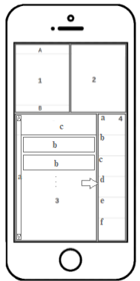
1. Video player for debates or proxy’s and delegate’s profile photo.
- Shows date and location of the debate or proxy’s and delegate’s name. Mention of live stream if its the case.
- Shows name of the debate.

2. Presents a summarized version of the debate’s work order or an autobiographic description of the proxy or delegate (this autobiographic description must be uploaded by each user).

3. Presents what’s chosen in the menu in section 4 (by default the last option chosen by the user).
- Scroller.
- List of available options.
- Header for section 3.

4. Is a menu that can be hidden with options:
- Private messages or recent replies to topics being followed.
Wireframe 1) Smartphone
wall view
- Shows a list of recent debate activity.
- Recent activity from delegates.
- Recent activity from topics on the forum close to the area of residency of the user.
- Recent activity from Cores, if the user is a member of one. Otherwise show recent activity from popular topics in the forum.
- Recent activity from unfollowed trending topics on the forum.

Recent activity means showing indicators such as in the case for topics on the forum as the name of the topic, the number of people actively reading the topic, alerts for new posts, consensus percentage, time left of evaluation period, etc.. Section 3 can also show a snippet of the topic or of the most recent reply.
Desktop wall view
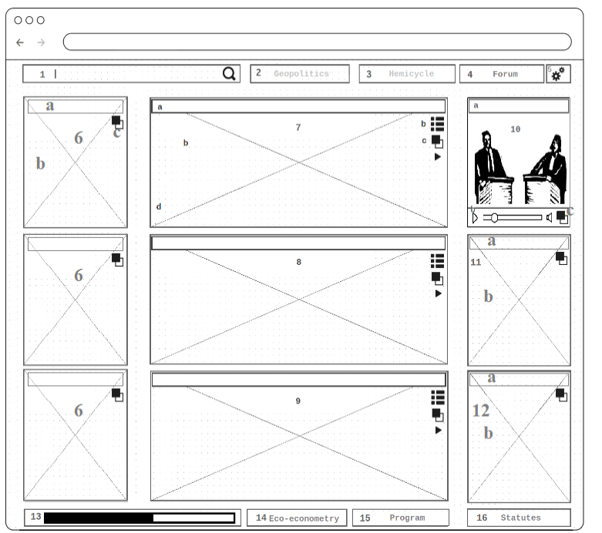

Wireframe 4) Desktop wall view

PICTURE 1 OF PROGRESS BAR COMO ESCREVI NAS NOTAS

PICTURE 2 OF PROGRESS BAR COMO ESCREVI NAS NOTAS
1. Search bar that looks into forum, profile and institution’s views content.

2. Button to Geopolitics view (unavailable in MVP).

3. Button to Hemicycle view (only partially available in MVP).

4. Button to Forum.

5. Button to user profile.

6. Last activity from favoured/participating Cores.
- Header.
- Body text with a summary snippet of the debate.
- Brings the selected Core to front by expanding the box to take the space of sections 7, 8 and 9.

7. Last activity from National Council and International Council.
- Title header.
- Body text with a summary of the debate.
- Brings the selected political organ to front by expanding the box to take the space of sections 7, 8 and 9.
- Play the video record of the highlighted meeting in box 10.
- List all recent National Council and International Council recent meetings.

8. Last activity from Local Council.

9. Last activity from Municipal Council and Inter-municipal Council.

10. Video stream of last debate.
- Title header.
- Media controls.
- Go to debate’s view.

11. Last activity from delegates on the forum.

12. Last reply to user’s posts on the forum.

13. Progress bar. In the progress bar the top 5 favourite policies that are followed by the user are shown in relation to their respective rate of approval and evaluation period. An alert is shown as considerable progress is made.

14. Button to Eco-econometric report (unavailable in MVP).

15. Button to party program editor.

16. Button to party’s statutes.

Desktop debates view
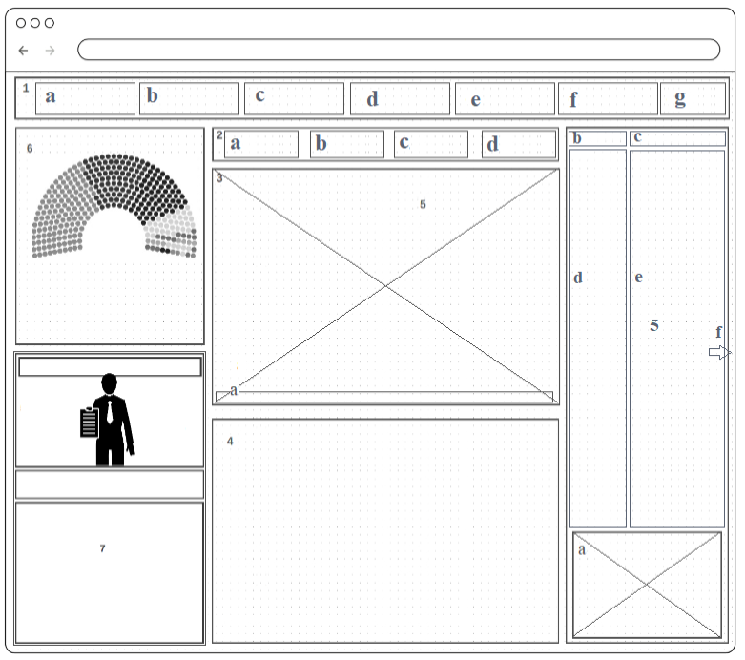

Wireframe 5) Desktop debates

1. Main menu:
- Start recording button. This button should only be clickable to users authorized as secretary-geral and only during the appointed debate. When clicked pops-up a window where the user can preview what’s being recorded and access camera and microphone settings.
- Drop down menu with selection of debates.
- Post code for the administrative area considered in b.
- Button link to the institution’s page if applicable from selection made in b.
- Button link to forum view.
- Button link to wall view.
- Go back button.

2. Debates navigator:
- See the table (who is secretary-geral or members of the board). If the user is part of the debate panel then he/she should be able to pick a secretary-geral/board by typing in the names.
- Work order button link. Shows on section 4 information regarding the debate’s main topics for discussion, what organ is to be presented and other relevant information regarding the debate.
- Shows the policies and decisions that were voted during the debate and their respective links to the forum topics. Also, for members who are participating in the debate, an option is given to poll user’s who are watching.
- Presents in box 4 the summary of the debate if applicable. Otherwise show assads. This is the default active option.

3. Debates video stream. Shows video recordings of debates that occurred in the past or that are being recorded live.
- When hovered with the mouse the timeline appears. Otherwise it’s hidden.
- Recording button. To be used in order to initiate new debates.

4. Debate summary, important links and work order. Also used to present content chosen in box 2.

5. Interactive chat-room. The chat-room should support at maximum 10 people at the same time. If more people want to join conversation during the debate a new instance of the chat-room is created to accommodate. Each chat-room maybe given the name of a Greek philosophers, important scientists or popular singers (for a large number of users there’s a need for a bigger user base). Users are allowed to join specific chat-rooms (if there’s room available by an option the menu).
- Input text area.
- Shows number of people active.
- Shows the name of the chat-room.
- Shows usernames of the members of the chat-room with the corresponding timestamp.
- Comments, chat area.
- Changes the user randomly to the next chat-room available.

6. Hemicycle/ coloured diagram of the participants in the debate

7. Profile viewer /preview of the selected participants in the debate
Smartphone debates view

This is an expanded version of the wall view when the video or the avatar box is selected.

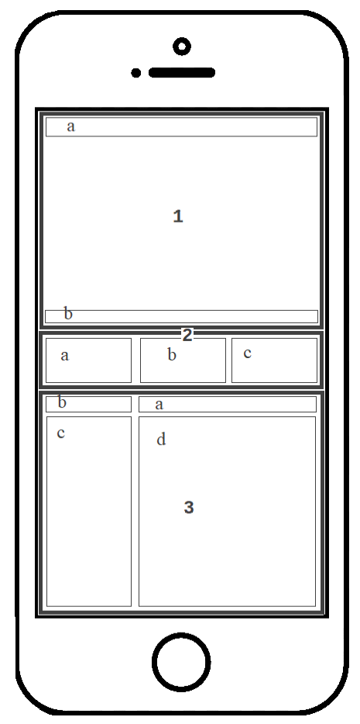

1. Expanded version of the video debate player.
- Date, location and live status.
- Political organ’s name.

2. Important links info related to the debate.
- Link to the institution’s view
- See work order for the debate.
- See chat-room or forum snippets from the corresponding topic of the debate.

3. Shows work order if option b is selected or if c is selected (box 2):
- Name of the chat-room.
- Number of active users and live status.
- Usernames.
- User’s chat.

Wireframe 2) Expanded
smartphone wall view

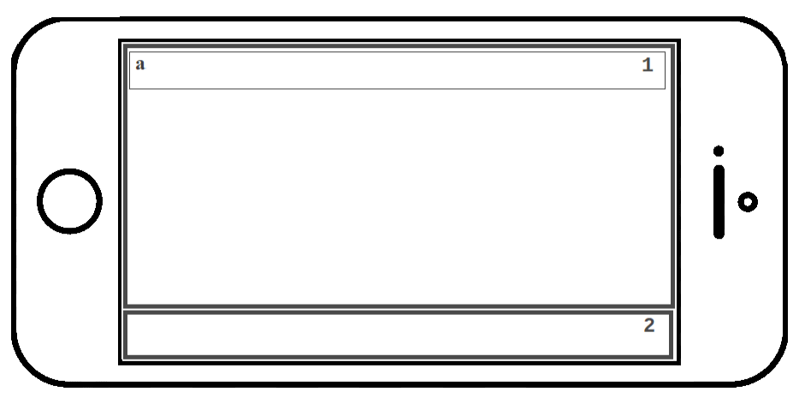

Wireframe 3) Full-screen smartphone tilted wall view

1. Full screen of the video debate.

2. Scroller of quotes with more likes from the chat-room or from the forum topic connected to the debate.
- Date of recording, location of the debate and stream status. Name of the organ debating.
Smartphone as a voting controller

As discussed before the smartphone can function as a voting device to be used exclusively by participants during political debates.

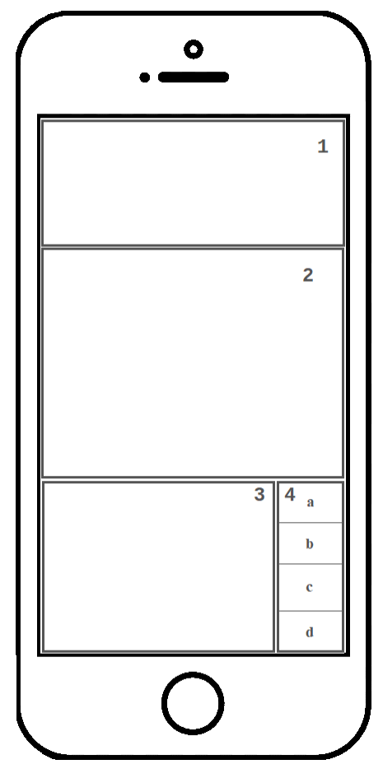

1. Poll ID as well as other relevant information such as area of governance, scope, etc..

2. Proposal’s body text.

3. Poll options.

4. Vote for, Delegate vote, Vote null and See results buttons (other options may be appropriate such as Vote against or other more specific options…). Once a vote is cast then box 3 shows voting results and 4 changes to:
- Recast vote.
- Change delegate.

Wireframe 6) Smartphone
as a voting controller

Likewise the same layout should appear in the desktop version as a pop-up whenever a voting prompt is asked, unlike the smartphone prompt which is to be used exclusively during debates.
Votes cannot be cast unless a fingerprint at least is used to authenticate as well as the insertion of a code sent to the user’s alleged phone number.
Smartphone profile view

Basic user settings such as privacy, notification settings, nickname.

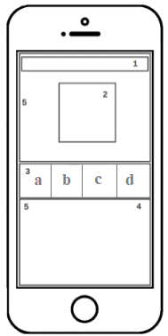
1. Name (and reputation if applicable). Reputation is a variable usually hidden unless the user is seen as suspicious our disrespectful.

2. Profile photo.

3. Menu:
- Link to a favoured social network where the user is active: Linkedin, Twitter, etc..
- Blog.
- Private messages.
- Other contacts (e-mail, telephone, etc..).

4. Recent activity in order of importance:
- Last debate where the user participated.
- Last votes cast by the user.
- Last posts on the forum.
Wireframe 7) Smartphone
profile view
5. Customized background image.

If the user’s activity is set to private then the module 4 becomes hidden:
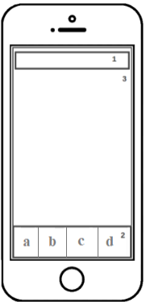

Wireframe 8) Smartphone profile view with privacy settings on
1. Same as 1 from wireframe 7.

2. Same as 3 from wireframe 7.

3. Same as 5 from wireframe 7.
The second view of profile consists of a social graph that represents the relationships between users of the dapp. This section of the view can be set to public, private or accessible to friend’s proxies and delegates only.

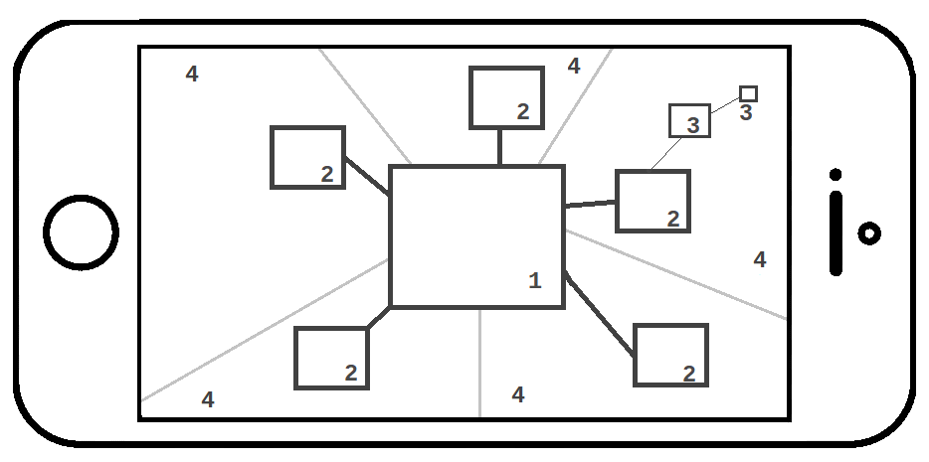

Wireframe 9) Smartphone profile when tilted horizontally

1. Central profile, with a profile photo at the centre, to which other profiles are directly linked. A link means the central figure delegates the vote to the other party.

2. Profile photo to whom user 1 has delegated the vote on a political category represented by divisions delineated by 4. A second order link can be represented from user 2 to a 3rd user. Third order delegations can be hinted to exist but are not easily visible without further zooming. When the user double clicks or zooms in with finger gestures on a second or third order delegate profile it takes the place of the central profile 1.

3. Third level delegation profile.

4. These are different political divisions such as; healthcare, foreign policy, etc.. coloured differently. This is a way to group delegates in a clear and simple manner.

Suggested reading:

“Power BI Custom Visuals - Social Network Graph” video on Youtube,
https://www.youtube.com/watch?v=PS_L2-YJTXk
Desktop user view
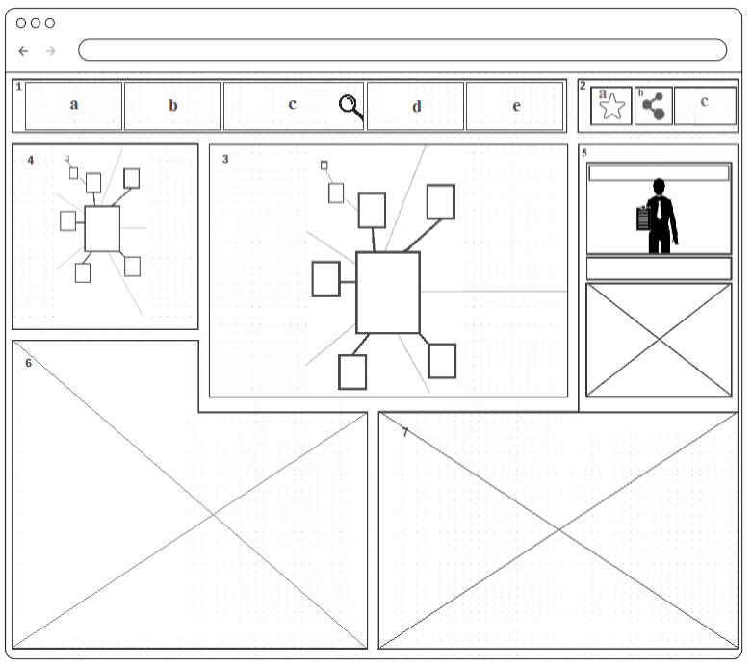

Wireframe 10) Desktop profile view

1. Menu:
- Back to previous view.
- Access user’s profile view.
- Search bar that searches the user base matching name and e-mail.
- Affinity button; shows profiles that the user has more affinity with such as by evaluating recent activity measured by the number of likes, votes on certain policies or time spent watching the same topics on the forum.
- Invite button. Shows passphrase, if available, that can be used to invite new users to the platform.

2. Menu related to the profile viewer in section 5.
- Add user as friend.
- Add user as proxy.
- Delegate area of governance to user.

3. Social graph of the user profile in view on section 5.

4. Second-order social graph of highlighted (selected user) in the first order social graph. By default when no user is selected from 3) then show a zoomed out view of the first order social graph 3)

5. Profile view of the user centred in the social graph of box 3. Default is own user’s profile.

6. Overview of last activity of the user centred in the second-order social graph. When no user is selected then by default shows messages assorted from delegates or proxies, if applicable. Otherwise show comments from the forum.

7. Overview of last activity of the user highlighted user in section 5.
Desktop institution / core view
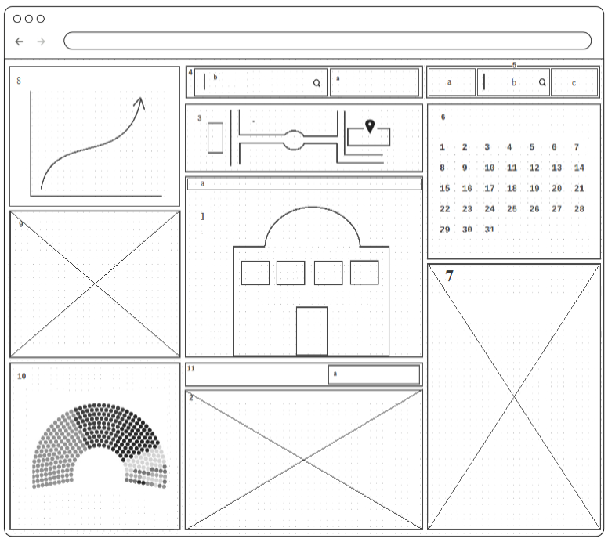

Wireframe 11) Desktop institution / core view
1. Institution banner: photo of the building or custom image uploaded by the Core group.
- Name and location.

2. Recent activity of the highlighted public institution, public organ, public service or party’s core group. Should make use of a scrapper to gather and show information from official public sources if necessary.

3. Map preview and navigation for geolocation.

4. Menu for public institutions (organs and services) and for party’s Cores:
- Drop down menu with options for organs and services.
- Search bar.

5. Menu:
- Show historic navigator for political activity in 7.
- Search bar for particular political events.
- Back to default recent political activity in 7.

6. Calendar of political events occurring in the institution’s organs and building. If a date is selected on the calendar then detailed information is presented in 7.

7. Last activity from selected organ. If a service is chosen in the menu 11 instead show the contacts / working hours of these services.

8. This frame shows a description of the institution, organ, service or core highlighted. Can also be used to show statistical data.

9. Announcements of the Institution/ Core

10. Hemicycle preview: visual representation of the members of organs belonging to the institution with visual cues as regards to political party affiliations. For institutions by default the Execution board.

11. Menu to choose from institutions services, organs, asda
- Drop down menu to choose from different services by the Institution. If it is a Core that is presented instead make this a customized drop down meu.
- sadads
Smartphone institution / core view

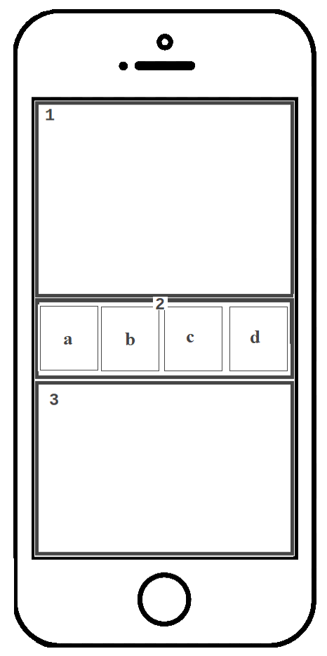

1. Banner image of the institution / core. In the case of public institutions, a photo of the building should be presented.

2. Menu:
- Contact info.
- Services.
- Agenda.
- Organs.

3. Last activity from the Institution/ core. For public institutions a scrapper may be used to gather data from the official websites.

Wireframe 12) Smartphone
institution/core view



Wireframe 13) Smartphone horizontal institution/core

1. Google map with the location of the public building in case of viewing an Institution. For Cores the horizontal view should show ??
Smartphone landing page, program and work order view

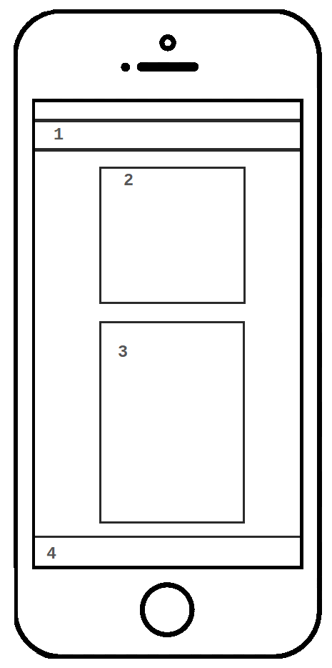
Landing page layout:
1. Snippet from the forum trending topics and
message from the president.

2. Logo of the political party.

3. Main menu:
- Login or register.
- asdaasd
- asdasd

4. Footer:
              - About.
              - FAQ.
              - Contacts.
              - Support.

Wireframe 18) Smartphone
landing page
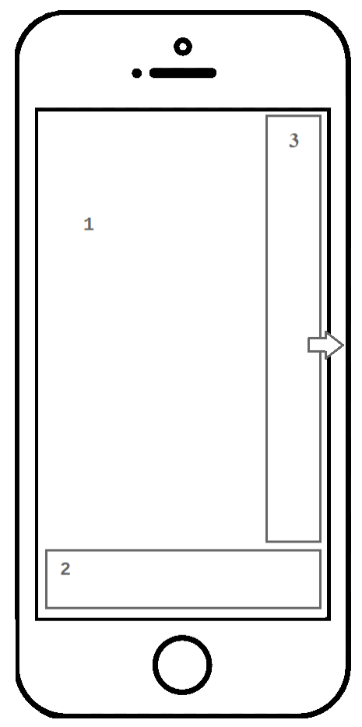
The same layout is used to view the political party’s program ass well as the work order for each debate:
1. PDF view of the political program or work order.
2. Search bar for content within the document.
3. Vertical show and hide menu where the user can filter and navigate through policy categories in the case of party’s program. For the view showing the work order this menu remains hidden.

Wireframe 17) Smartphone
political program viewer

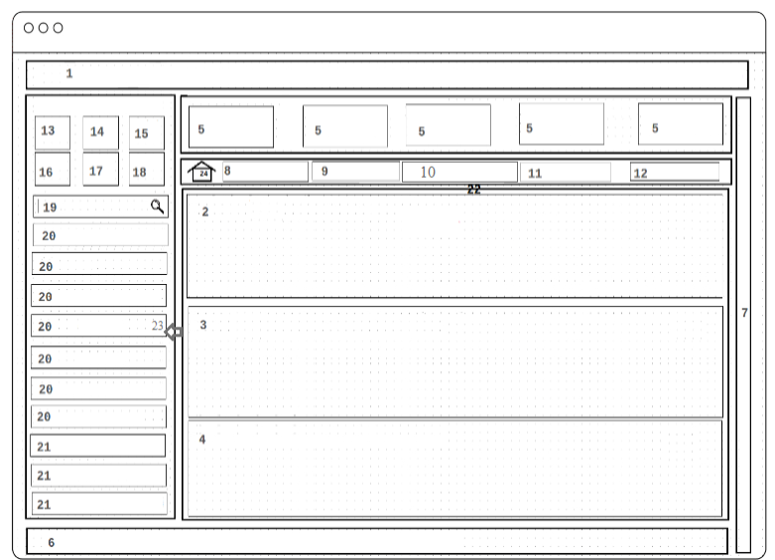
Forum view

Wireframe 15) Forum

All the data published on the forum is to be saved on IPFS while the voting results and the corresponding IPFS hash should be kept on Algorand. The design of the forum is inspired by traditional bulletin boards like phpBB.

1. Announcements text scroller. Shows a message from the president or scrolls alerts for upcoming debates or postponed events.

2. Trending topics

3. Trending from favourites

4. Recent topics / replies

5. Customizable Core button links. Shows random cores if the user has none by default.

6. An expanded progress bar as seen in the wall view.

7. Vertical scrollbar.

8. Vote on new policies.
- When a particular policy is in view the button changes to Vote and when clicked opens up voting pop-up prompt.

9. Propose new policy.
- When a particular policy is in view the button changes to Constitutional Conformity.

10. Followed policies button. Otherwise when a particular policy is in view the button changes to Feasibility study.

11. Discuss policies button. Opens the forum chat-room that takes the space of sections 2, 3 and 4.
- When a particular policy is in view the button changes to Comparative economical analysis.

12. See party program.
- When a particular policy is in view the button changes to Execution plan.

13. Button link to forum category: National discussion.
14. Button link to forum category: Intermunicipal discussion.
15. Button link to forum category: Municipal discussion.
16. Button link to forum category: Local discussion.
17. Button link to forum category: International discussion.
18. Core discussion.

19. Search bar

20. Political categories filter: Health and environment, Urban planning, Natural resources, Culture, Taxation, Foreign affairs, Transportation, etc..

21. Favourite topics shortcuts

22. Shows 3 most recent forum topics by category or shows instead a chosen policy.

23. The menu can be hidden.

23. Go to forum categories default view.
Desktop program view

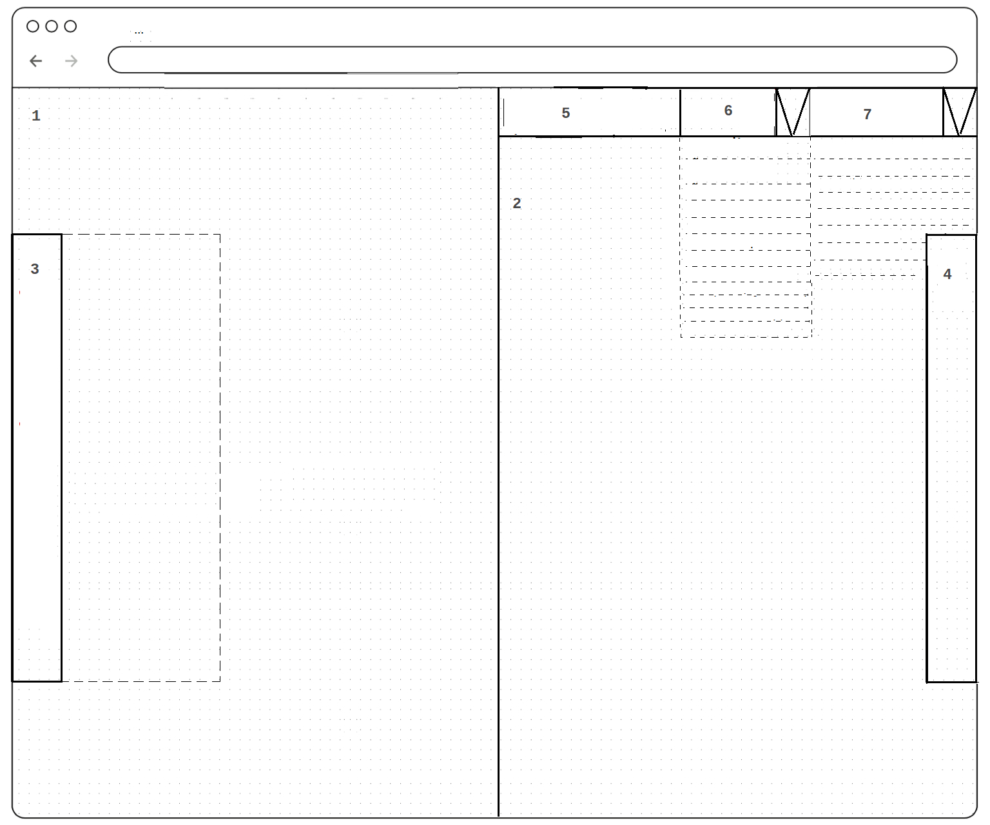

Wireframe 16) Desktop political program editor

Many policy proposals will be generated by the dapp users, some will be validated by the Legal Committee and improved by the Coordination while others will be refused. The ones that pass and have sufficient support (votes) will be evaluated eco-economically by the SCIENTIFIC COMITEE / COORDINATION and debated by some user’s groups as defined. The last step of all these procedures is to generate a political program and this requires a specific view. This section of our MVP the dapp should be able to:
List all approved policy proposals in a general form, a resumed version and generate a second list by sector.
Do a quick automated financial analysis of their total budget.
Give the choice to the user to either insert or remove a given policy from the political party program.
Export the full political party program in PDF format.

1. Program PDF View

2. Policy editor

3. Pop-up navigation menu for the program PDF view

4. Pop-up options menu for Policy editing (adding/ removing policies from party program)

5. Search bar

6. Filter: Trending, Urgency, National/municipal/etc Council, Economical impact, Personal queue, Local/global rate of approval, publication date..

7. Filter by sector: Health and environment, Urban planning, Natural resources, Culture, Taxation, Foreign affairs, Transportation
Desktop landing page


Wireframe 19) Smartphone landing page

- Name of the political party

- Logo of the political party

- Menu: Register, log-in, lost credentials

- Scrolling header with a message from the President.

- Fade in/out quotes of the most liked user publication aka post of the week (min. 250 characters).

- Fade in/out quotation of the most recent user publication with a minimum of 250 characters.

- Short manifesto.

Eco-econometric report



Wireframe 20) Eco-econometric

Lastly, but not least, we consider that regardless of the quality of our communications dapp platform, no correct political position can be made without the right scientific basis, in particular as to regards economics or environmental factors. That is why on a section of our a dapp, we should have a view dedicated to this. The idea here is to separate all that is subjective and prone to human opinion and present exclusively precise mathematical data; hence eco-econometry. The more informed people are, the better decisions are made.
This view necessarily needs scrapping from public sources and the best way to do this in integration with blockchain techniques is with the use of an oracle.

1. Tax income menu.

2. Spending menu.

3. Graphical visualizer.

4. Variable visualizer for tax income.

5. Variable visualizer for spending.

6. Spending balance.

7. Tax income balance.

8. Total balance.
Below is an example of what such a page could look like although the example is given for the economics of cryptocurrencies and our aim is to encompass as much of the economy, including population health and air quality data for example, as possible.

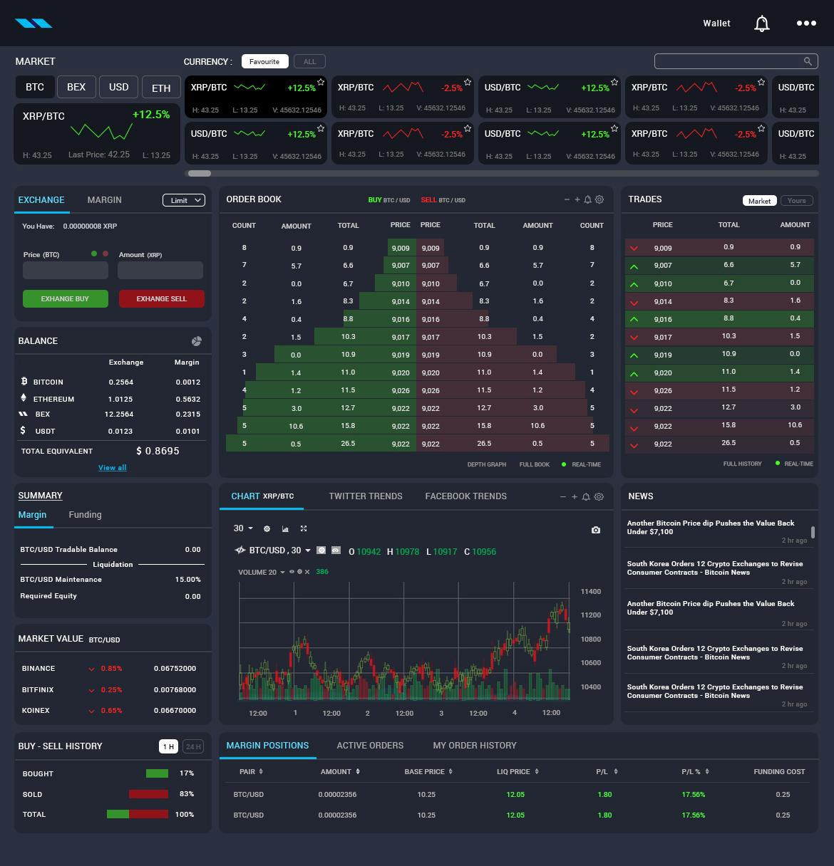
Picture 15) Example of a futuristic UX for the eco-econometric report,
in this case an economical account of the cryptocurrencies market

Hemicycle
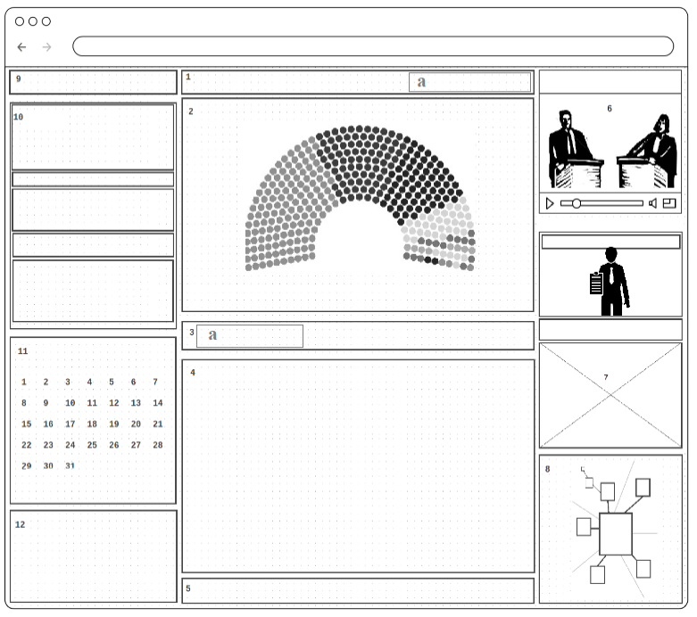

Wireframe 21) Hemicycle view

Some of the features of the Hemicycle view are left outside of the MVP because for its functioning a lot of real-time data needs to be drawn from outside sources, by doing scrapping techniques, using RSS feeds, etc. and unfortunately there’s no standardized sources across different countries and political institutions so there’s a need to do some research in this area. Example is representing the national parliaments and its activity.
This is to represent in real-time actions that are taking place either in parliament, town hall meetings or during some of the political party organs. An example of what we are proposing here can be seen at NAME OF THE INSTITUTION, LINK. Our intention then is to extend its functionalities to better adapt to our needs.
First each circle represents a seat. The colouring of each circle should depend on the viewing options. We could choose to view by political affiliations. Or alternatively we could choose to view by political position on a particular matter. In a more advanced version views by gender, age, or some other parameters could be added though these are not the main concerns.
1. asaads
- Drop down menu select from different Hemicycles.

2. Graphical representation (hemicycle) of a political organ.

3. asdasdada
- Vote for the composition of the Hemicycle.

4. Recent activity of the highlighted Hemicycle.

5. asdads

6. Last debate done by the highlighted Hemicycle.

7. Profile preview/view of the person highlighted in the Hemicycle.

8. Social network graph of the person in view highlighted in the Hemicycle.

9. Institutions menu/navigator.

10. Institution view/preview to which the highlighted Hemicycle belongs.

11. Calendar of activities/events of the highlighted Hemicycle.

12. asdadadad

AQUI É FEITA A ESCOLHA DA COMPOSIÇÃO DOS DEBATES.
The word hemicycle comes from ancient greek semi (hemi) and circle (cycle) and is a term coined to represent the parliament where politicians gather and vote on policies. Most parliaments use the form of a semi-circle although different geometries may occur such as in England or in Australia. Here, for our dapp we will use a view consisting of a semi-circle consisting of many small circles positioned accordingly such as in the following picture:
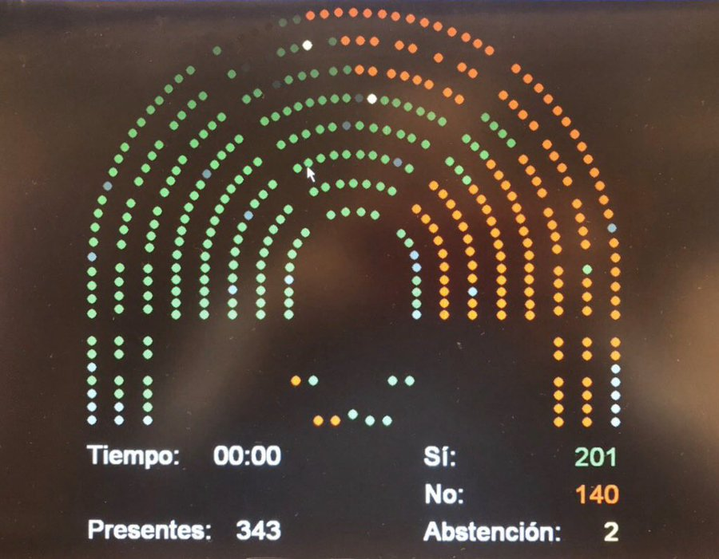
Picture 16) Example of an UX for the hemicycle view

For groups up to 10 people a circle can be used as the optimal disposition of participants. For groups between 11 to 50 (arbitrary, ver quantos membros tem a CCEJ) a disposition similar to the British is most appropriate. For larger groups a semi-circular approach is the best.

Suggested reading:

“Interactive seating plan of the hemicycle of the European Parliament”,
https://www.europarl.europa.eu/hemicycle/index.htm?lang=en&loc=str#

Audio transcription

The idea is to have in the dapp a feature that is used to keep automatic written accounts of the debates; audio-to-text in addition to the video and audio records much like Youtube is already doing at the present moment with CC captions… This feature is useful to facilitate the tasks, perhaps even substituting depending on the quality of the software, of writing down the summaries of the political debates. Usually this is done by a trained professional specially assigned to do so at political events or during court trials. In our case this role is assigned to the “secretary-general”. PAGAR EM CRYPTOMOEDAS O TRABALHO DO SECRETARIO GERAL
This feature is also desired in order to promote software inclusiveness; so that the audio(auditive?) impaired community can participate fully. Transcribing text-to-audio is also helpful for the blind community that may want to participate in our platform much like in the form of audio reading much like Windows robot voice, These are important aspects often unthought of and because any political effort should always strive to include and protect minorities we consider this an important milestone in our roadmap.

Suggested reading:

“10 Good Open Source Speech Recognition Systems” by Simon James on FOSS Post,
https://fosspost.org/open-source-speech-recognition-2021/

https://ai.facebook.com/blog/wav2vec-unsupervised-speech-recognition-without-supervision

https://twitter.com/facebookai/status/1399750058883444738

https://github.com/pytorch/fairseq/tree/master/examples/wav2vec/unsupervised

https://arxiv.org/pdf/2105.11084.pdf

Artificially intelligent political compass

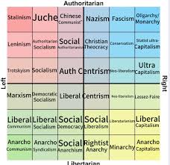
A political compass is a series of questions, or a quiz, that is scored in such a way as to classify the partaker within a set of different political categories. This can be done in a number of different ways with the most common being the division between left, right, capitalist, communist or libertarian, authoritarian:

Picture 17) A political compass

Other political compass models go farther than associating the partaker with a given political philosophy and go as far as to indicate what kind of politics one might be interested in… for example someone that states he is in favour of A may also be for B and probably against C. This is a more complex …. What we propose here is to add to machine learning to these algorithms; the goal then is to guide the user through a myriad of different proposals.

Suggested reading:

Political compass entry on Wikipedia, en.wikipedia.org/wiki/Political_compass

“Patching Democracy – a short introduction to Voting Advice Applications” by Till Sanders, 2020, https://www.youtube.com/watch?v=UGkGsCpC5M8

“Quiz(zes): Where are you on the political spectrum?” article on Medium, https://medium.com/@otakuproxy/quiz-zes-where-are-you-on-the-political-spectrum-17bd08bc234f

OpenElectionCompass, https://open-election-compass.com/

10Groups, https://10groups.github.io/

Government by algorithm entry on Wikipedia, https://en.wikipedia.org/wiki/Government_by_algorithm

"Why artificial intelligence will replace politicians" by Michihito Matsuda, 2018, Japan,
https://www.slideshare.net/MichihitoMatsuda/politics-2028-why-artificial-intelligence-will-replace-politicians-by-michihito-matsuda

Collaborative development

At the time of writing this project is backed by a new software powerhouse named R4wbit based in Lisbon, Portugal. It’s a team of software programmers...

linkedin link or website

You are invited to contribute to this project and occasional bounties with cryptocurrency rewards are done through GitCoin:

https://gitcoin.co/ repo

If you would like to follow up and add recent news regarding our dapp development to your blog or news platform you can use the following RSS feed (will be exclusively updated by the author of this document and only relevant information will be noticed):
LINK
Anyone who may want to be more directly involved and be a part of the development team please feel free to contact …

CONTACTO + FOTO DA PESSOA QUE VAI DAR A CÁRA AO PROJECTO (possivelmente eu)

COMMONS LICENCE (LICENÇA DE DISTRIBUIÇÃO DA APLICAÇÃO, AO ESTILO DE ALGORAND, GRATUITA MAS COM RESTRIÇÕES PARA INICIATIVAS PRIVADAS LUCRATIVAS)

LANÇAR BOUNTY PROGRAM: https://www.hackerone.com/ ????

BOUNTY PROGRAM É UMA IDEIA INTERESSANTE: https://en.wikipedia.org/wiki/Bug_bounty_program

https://www.bountysource.com/
https://github.com/bountysource/core/wiki/Frequently-Asked-Questions
Other interesting links

Interesting pages and pdfs that were not mentioned on the main chapters for some reason or another are mentioned here. They were not included to not interrupt the flow of the document but were considered useful for the understanding of the problematic at hand.

On blockchain:

Youtube series on blockchain at Berkeley University, https://www.youtube.com/channel/UC5sgoRfoSp3jeX4DEqKLwKg

A Simple Blockchain in Java,
https://dzone.com/articles/a-simplest-block-chain-in-java

Blockchain Implementation With Java Code,
https://dzone.com/articles/blockchain-implementation-with-java-code

Example of a simple blockchain with JAVA, https://medium.com/programmers-blockchain/create-simple-blockchain-java-tutorial-from-scratch-6eeed3cb03fa

“Ethereum JDBC driver implements a pure java, type 4 JDBC driver that executes SQL queries on Ethereum Blockchain”,
https://github.com/Impetus/eth-jdbc-connector/

Connecting to an Ethereum client with Java, Eclipse and Web3j,
https://kauri.io/connecting-to-an-ethereum-client-with-java-eclipse-and-web3j/b9eb647c47a546bc95693acc0be72546/a

Presto Interactive SQL Querying on Ethereum Blockchain,
https://github.com/xiaoyao1991/presto-ethereum

“Hydras and IPFS: A Decentralised Playground for Malware”, https://arxiv.org/abs/1905.11880

A Java implementation of the HTTP IPFS API,
https://github.com/ipfs/java-ipfs-http-client

“Terminal offers (...) all the tools needed to deploy and manage sites on IPFS”,
https://medium.com/coinmonks/terminal-co-ipfs-web3-deployment-simplified-da70efee7e74

Blockchain-based database entry on Wikipedia,
https://en.wikipedia.org/wiki/Blockchain-based_database

Algorand’s white paper, https://arxiv.org/abs/1607.01341

On smartcontracts:

Solidity, https://solidity.readthedocs.io/en/v0.6.2/

Clarity, https://docs.blockstack.org/core/smart/overview.html

Getting started with Smart Contracts and the Solidity language, https://ethereum.org/java/#getting-started-with-smart-contracts-and-the-solidity-language

“Creating your first Smart Contract on Hyperledger Fabric!” by Swetha Repakula and Morgan Bauer, IBM, https://youtu.be/U_0X11A16tsf

Smart Contracts and Chaincode, https://hyperledger-fabric.readthedocs.io/en/release-2.0/smartcontract/smartcontract.html

EthereumJ, https://mvnrepository.com/artifact/org.ethereum/ethereumj-core/1.12.0-RELEASE

Lightweight Java and Android library for integration with Ethereum clients,
https://web3j.io/, https://github.com/web3j/web3j

Intro to Blockchain With Ethereum, Web3j and Spring Boot: Smart Contracts, https://dzone.com/articles/intro-to-blockchain-with-ethereum-web3j-and-spring

Javascript SDK for interacting with Clarity smart contracts,
https://github.com/blockstack/clarity-js-sdk

Proof-of-personhood:

Proof of personhood entry on Wikipedia, https://en.wikipedia.org/wiki/Proof_of_personhood

“An Internet for Humans: Proof-of-Personhood Explained” on coindesk by Paula Berman and Divya Siddarth, 2020,
https://www.coindesk.com/proof-of-personhood-2030

“Proof-of-Personhood: Redemocratizing Permissionless Cryptocurrencies” by Maria Borge et al, published during IEEE European Symposium on Security and Privacy Workshops, Paris, France, 2017,
https://www.zerobyte.io/publications/2017-BKJGGF-pop.pdf

“Identity and Personhood in Digital Democracy: Evaluating Inclusion, Equality, Security, and Privacy in Pseudonym Parties and Other Proofs of Personhood”, Bryan Ford, Swiss Federal Institute of Technology in Lausanne (EPFL), 2020,
https://arxiv.org/pdf/2011.02412.pdf

On Sybil attacks:

“The Sybil Attack”, John R. Douceur, Microsoft Research,
https://www.freehaven.net/anonbib/cache/sybil.pdf

“Detection and Mitigation of Sybil Attack in Peer-to-peer Network”, Arpita M. Bhise and Shailesh D. Kamble, Yeshawantrao Chavan College of Engineering, Nagpur, India, 2016,
http://www.mecs-press.org/ijcnis/ijcnis-v8-n9/IJCNIS-V8-N9-8.pdf

“SybilGuard: Defending Against Sybil Attacks via Social Networks”, Haifeng Yu et al, http://www.math.cmu.edu/~adf/research/SybilGuard.pdf

“SybilLimit: A Near-Optimal Social Network Defense against Sybil Attacks”, Haifeng Yu et al, https://www.comp.nus.edu.sg/~yuhf/yuh-sybillimit.pdf

“DSybil: Optimal Sybil-Resistance for Recommendation Systems” Haifeng Yu et al, https://www.comp.nus.edu.sg/~yuhf/dsybil-oakland09.pdf

“A Sybil Safe Virtualization based Public Key Management Scheme for Mobile Ad Hoc Networks”, Renan Fischer et al, Brazil, 2014.
http://www.cyberjournals.com/Papers/Jan2014/01.pdf

“Detecting Sybil Attacks using Proofs of Work and Location in VANETs”, Mohamed Baza et al, 2019. https://arxiv.org/abs/1904.05845

“An RSSI-based Scheme for Sybil Attack Detection in Wireless Sensor Networks”, Murat Demirbas et al, State University of New York, NY, USA,
https://cse.buffalo.edu/~demirbas/publications/sybil.pdf

“A Blockchain-Based Hybrid Incentive Model for Crowdsensing”, Lijun Wei et al,
Department of Automation, Shanghai Jiao Tong University, Shanghai, China, 2020.
https://www.mdpi.com/2079-9292/9/2/215

“Combating Sybil attacks in cooperative systems”, Nguyen Tran, New York University, USA, 2012, https://cs.nyu.edu/media/publications/tran_nguyen.pdf

“Reputation management of peers to reduce the Sybil attack in peer-to-peer network”, Chirag R. Parmar and Chaita Jani, Kalol Institute of Technology & Research Center, South Korea, 2015, https://docplayer.net/11017574-Reputation-management-of-peers-to-reduce-the-sybil-attack-in-peer-to-peer-network.html

“FairCs—Blockchain-Based Fair Crowdsensing Scheme using Trusted Execution Environment” by Yihuai Liang et al, Department of Electrical and Computer Engineering, Inha University, South Korea, 2020,
https://www.researchgate.net/publication/341878926_FairCs-Blockchain-Based_Fair_Crowdsensing_Scheme_using_Trusted_Execution_Environment
Social deduction games:

Artificial Intelligence based Werewolf, http://aiwolf.org/en/introduction

“DeepMind’s MuZero picks up the rules of games as it plays” by Kyle Wiggers on VentureBeat, https://venturebeat.com/2020/12/23/deepminds-muzero-picks-up-the-rules-of-games-as-it-plays/

Wireless networks:

“Security of Wireless Sensor Networks: Current Status and Key Issues”, Chun-ta Li, 2010. https://www.intechopen.com/books/smart-wireless-sensor-networks/security-of-wireless-sensor-networks-current-status-and-key-issues

“Privacy protection in mobile crowd sensing: a survey”, Yongfeng Wang et al, World Wide Web, 2019,
https://link.springer.com/content/pdf/10.1007/s11280-019-00745-2.pdf

Software architecture:

Cryptographic primitive entry on Wikipedia, https://en.wikipedia.org/wiki/Cryptographic_primitive

“Man-in-the-Machine: Exploiting Ill-Secured Communication Inside the Computer” by Thanh Bui et al, Finland, 2018, https://www.usenix.org/system/files/conference/usenixsecurity18/sec18-bui.pdf

Other works in the field that though not directly related to our program are nevertheless interesting reads:

Blockchain (repeated entry,first entry is also named On Blockcahin):

Vitalik Buterin and Virgil Griffith white paper “Casper the Friendly Finality Gadget” on “a proof of stake-based finality system which overlays an existing proof of work blockchain”, https://arxiv.org/pdf/1710.09437.pdf

Vitalik Buterin on Why Proof of Stake?, https://youtu.be/x2QQiCKqjNY

Edward Snowden tweet on zero knowledge proof, https://twitter.com/Snowden/status/943164990533578752

IPFS integration with Ethereum example,
https://github.com/AdrianClv/ethereum-ipfs
Incentive based Proof-of-personhood:

“SenseChain: A blockchain-based crowdsensing framework for multiple requesters and multiple workers”, https://www.researchgate.net/publication/338029700_SenseChain_A_blockchain-based_crowdsensing_framework_for_multiple_requesters_and_multiple_workers

“Reputation and Reward: Two Sides of the Same Bitcoin”, https://www.researchgate.net/publication/303597418_Reputation_and_Reward_Two_Sides_of_the_Same_Bitcoin

“A Blockchain-Based Location Privacy Protection Incentive Mechanism in Crowd Sensing Networks”, https://www.researchgate.net/publication/328946547_A_Blockchain-Based_Location_Privacy_Protection_Incentive_Mechanism_in_Crowd_Sensing_Networks

Skynet, https://siasky.net/

Elrond, https://docs.elrond.com/

Code repos:

https://github.com/LogvinovLeon/estid-sig

OPENUBI PROJECTS: https://docs.google.com/spreadsheets/d/1BNvvqwY-JQVjk2pfATWnMcuslI5McoPsXTQx1JpaBmM/view#gid=0

https://sites.google.com/view/worldwide-direct-democracy/home : Worldwide Direct Democracy Networks

https://docs.google.com/spreadsheets/d/1Q9sU5WICEZtYyM47JqeUjKVEpT3VNtBnlg4rZkxKP6w/edit?ts=603881f8#gid=1673818635 : Scanning -Links for Politics and Governance

https://www.stat.berkeley.edu/~stark/Vote/

https://pkddownloadsg.icao.int/

